**CLOUDINARY SFCC CARTRIDGE**

**Test Cases**





**Table of Contents**

Jobs 4

Cloudinary - Upload product assets 4

Cloudinary - Upload content library assets 5

Cloudinary - Upload catalog assets 6

Cloudinary - Delta upload library assets 7

Cloudinary - Delta Upload catalog assets 8

Cartridge Operation Modes 10

Map Assets using tags and meta data in Cloudinary 10

PLP 10

Swatches 10

Mini Cart 11

Cart 12

Shipping 12

Cloudinary Gallery Widget for PDP 13

Global Level 13

Product Level 14

Variation Level 15

Cloudinary Video Player 16

Global Level 16

Product Level 17

Variation Level 18

Product Asset Transformations 19

Global Level Transformations 19

Catalog Level Transformations 20

Product Level Transformations 21

Responsiveness 22

Map Assets Using View-types in Catalog 24

PLP 25

Swatches. 25

Mini Cart 26

Cart 26

Shipping 27

Cloudinary Gallery Widget 28

Global Level 28

Product Level 29

Variation Level 30

Cloudinary Video Player 31

Global Level 31

Product Level 32

Variation Level 33

Product Asset Transformations 34

Global Level Transformations 34

Catalog Level Transformations 35

Product Level Transformation 36

Responsiveness 37

Use existing website URLs to auto upload into Cloudinary and deliver 39

PLP 39

Mini Cart 40

Cart 40

Shipping 41

PDP 41

Product Asset Transformations 42

Global Level Transformations 42

Catalog Level Transformations 43

Product Level Transformations 44

Library Assets 45

Map assets using SFCC Path 45

Use existing website URLs to auto upload into Cloudinary and deliver 46

Global Level Transformations 47

Library Level Transformation 47

Category assets 48

Map assets using SFCC Path 48

Use existing website URLs to auto upload into cloudinary and deliver 49

Category Transformations 50

Global level 50

Catalog Level Transformations 50

Category Level Transformations 51

# Jobs

## Cloudinary - Upload product assets

* Open Business Manager > Administration > Jobs, Open “Cloudinary - Upload product assets” job and go to job steps, Open “UploadProductLargeImages”, notice there are two options in “CLDJobExecutionMode” Select the Debug mode and add assets you want to upload in “CLDNumberOfAssets” and save.
* The other two job steps “UploadProductSwatchImages” “UploadProductVideos” are for swatches and vides respectively, these steps also have debug mode to run jobs with limited assets.

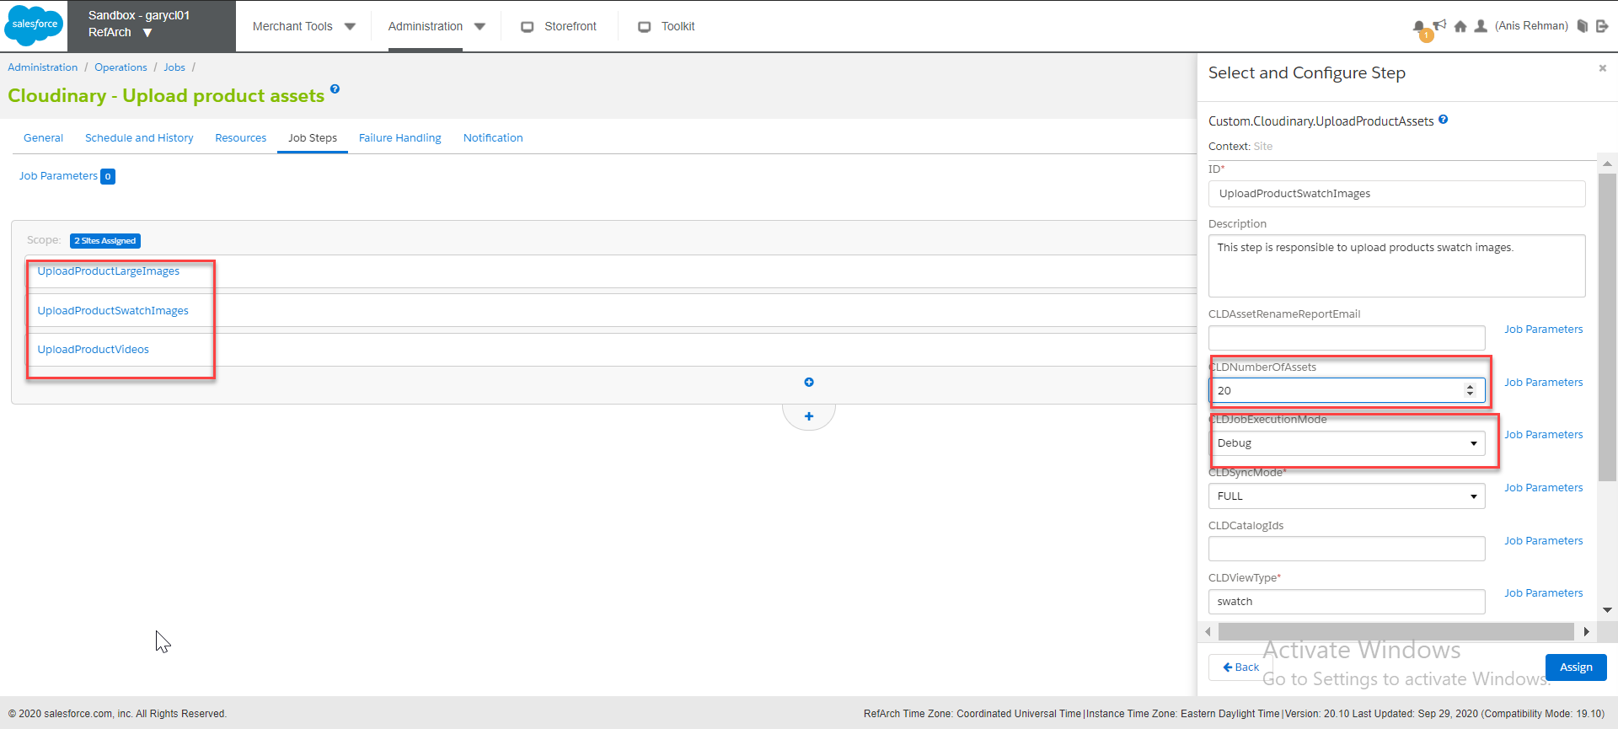

* Execute the job and after successful completion, the product assets will be uploaded to Cloudinary
* Open Business Manager > Administration > Jobs, Open “Cloudinary - Upload product assets” job and go to job steps, Open “UploadProductLargeImages” notice there are two options in “CLDJobExecutionMode” Select the prod mode, in this mode user doesn’t need to add number of assets because the prod mode will upload all the product assets.

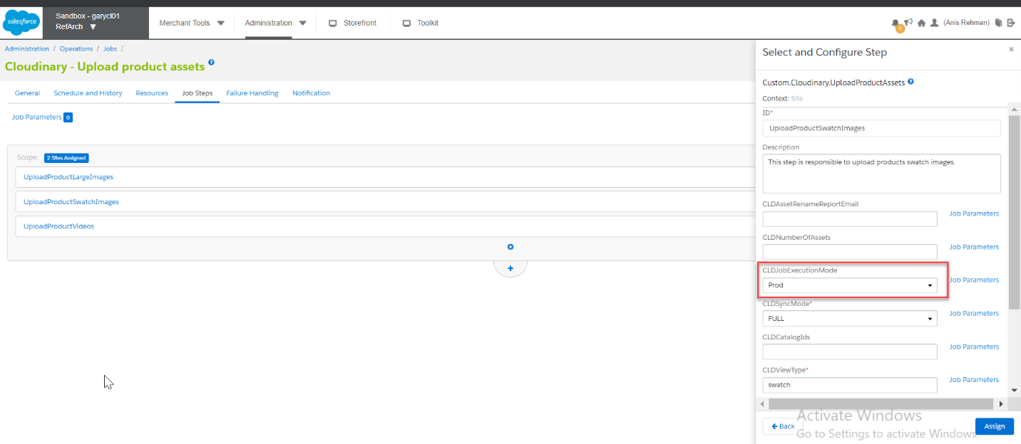

## Cloudinary - Upload content library assets

* Open Business Manager > Administration > Jobs, Open “Cloudinary - Upload content library assets” job and go to job step “UploadContentLibraryAssets” notice there are two options in “CLDJobExecutionMode”. Select the Debug mode and enter number of assets you want to upload in “CLDNumberOfAssets” and save.

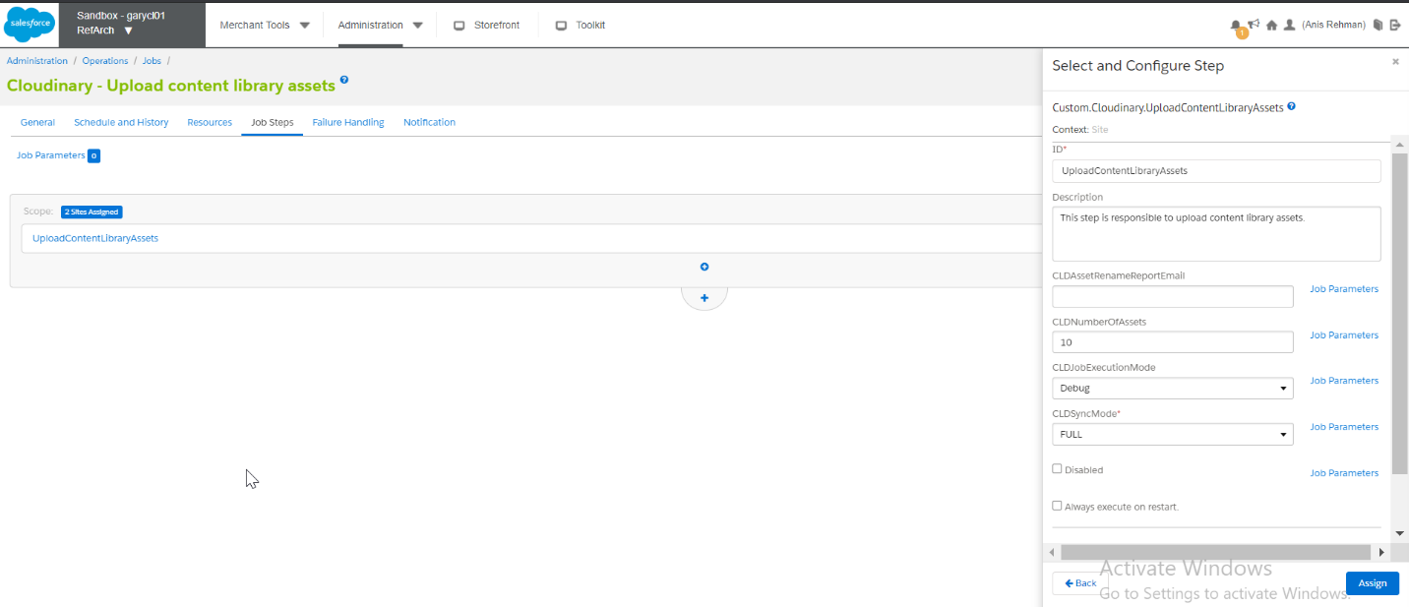

* Execute the job and after successful completion, the product assets will be uploaded to Cloudinary
* Open Business Manager > Administration > Jobs, Open “Cloudinary - Upload product assets” job and go to job steps, Open “UploadContentLibraryAssets” notice there are two options in “CLDJobExecutionMode” Select the prod mode, in this mode user doesn’t need to add number of assets because the prod mode will upload all the content library assets.

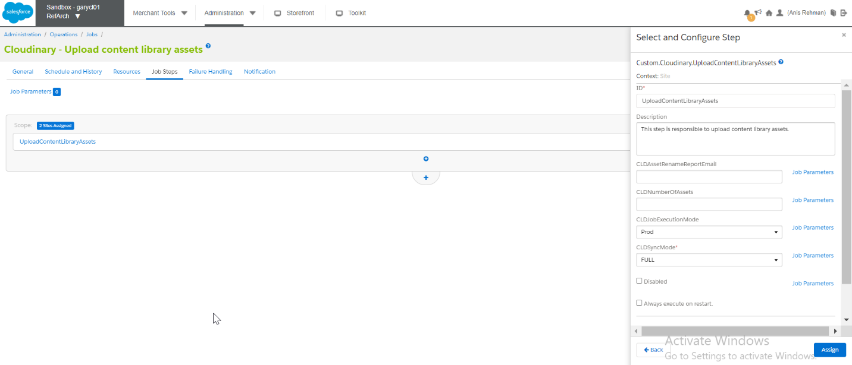

## Cloudinary - Upload catalog assets

Open Business Manager > Administration > Jobs, Open “Cloudinary - Upload content library assets” job and go to job step “UploadCatalogAssets” notice there are two options in “CLDJobExecutionMode”. Select the Debug mode and add assets you want to upload in “CLDNumberOfAssets” and save.

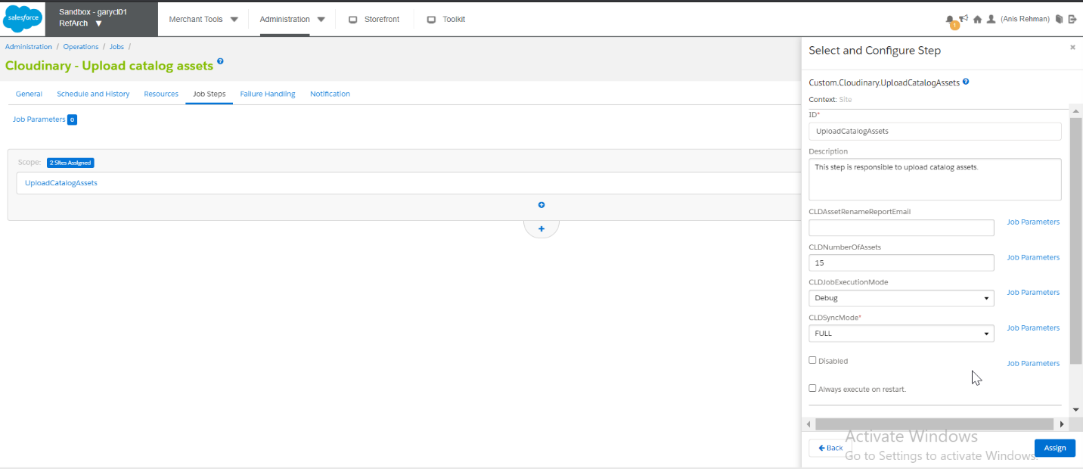

Execute the job and after it successfully completes, the product assets will be uploaded to Cloudinary

Open Business Manager > Administration > Jobs, Open “Cloudinary - Upload product assets” job and go to job steps, Open “UploadCatalogAssets” you can see there are two options in “CLDJobExecutionMode” Select the prod mode and in this mode user doesn’t need to add number of assets because the prod mode will upload all the catalog assets.

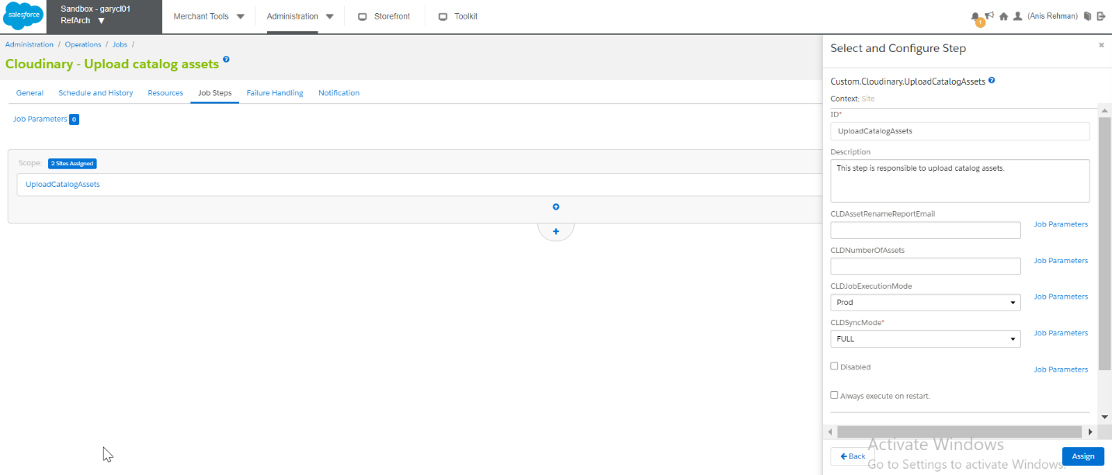

## Cloudinary - Delta upload library assets

* Open Business Manager > Administration > Jobs, Open “Cloudinary - Delta upload library assets” open job steps and notice “DELTA” is preselected in “CLDSyncMode”.
* “DELTA” Option is to sync assets from specific time.

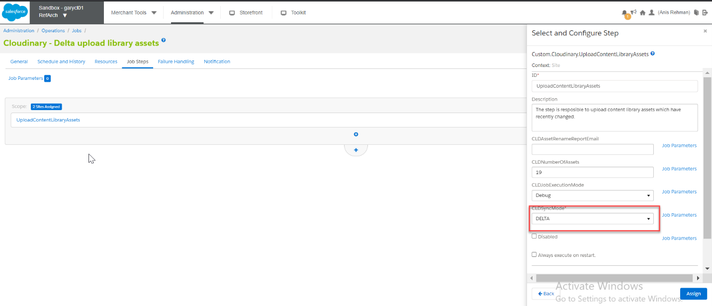

* Execute the job and after it successfully completes, the assets will be uploaded for the selected time period.
* Open Business Manager > Merchant Tools > Custom Site Preference Groups > Cloudinary Jobs Configurations > Content Library Job Last Execution Date; set the execution date.

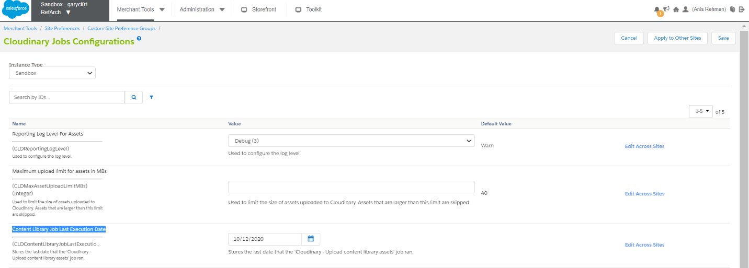

## Cloudinary - Delta Upload catalog assets

* Open Business Manager > Administration > Jobs, Open “Cloudinary - Delta Upload catalog assets” open job steps and notice “DELTA” is preselected in “CLDSyncMode”.
* “DELTA” Option is to sync assets from specific time.

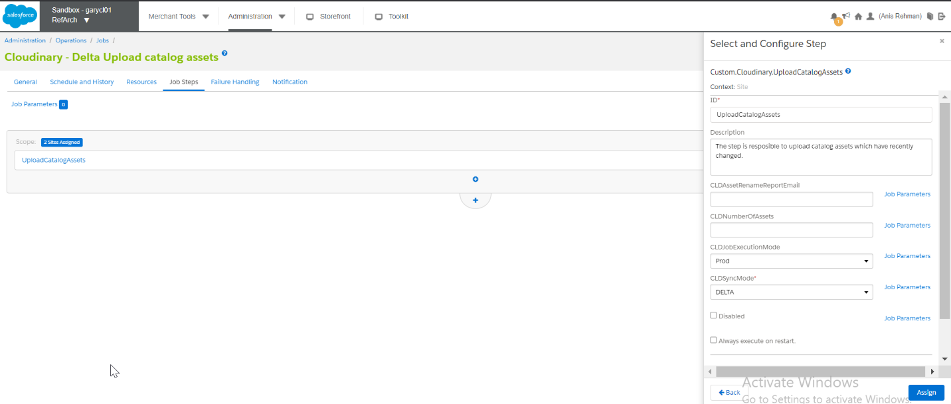

* Open Business Manager > Merchant Tools > Custom Site Preference Groups > Cloudinary Jobs Configurations > Content Library Job Last Execution Date; set the execution date.

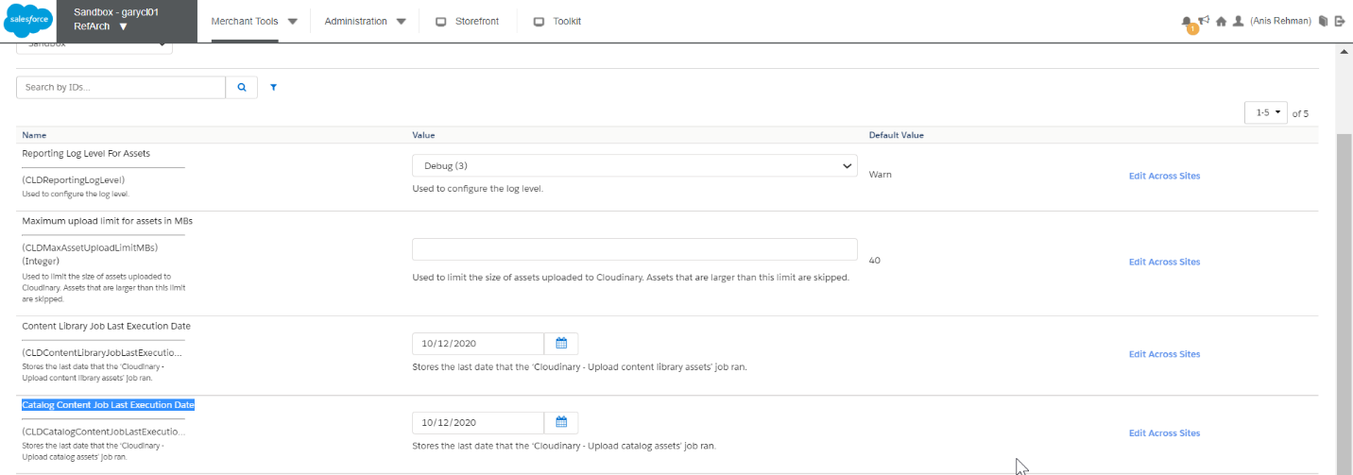

# Cartridge Operation Modes

## Map Assets using tags and meta data in Cloudinary

* Open Business Manager > Custom Preferences > Cloudinary Asset Management Configurations and select the cartridge operation mode “Map Assets using tags and meta data in Cloudinary”

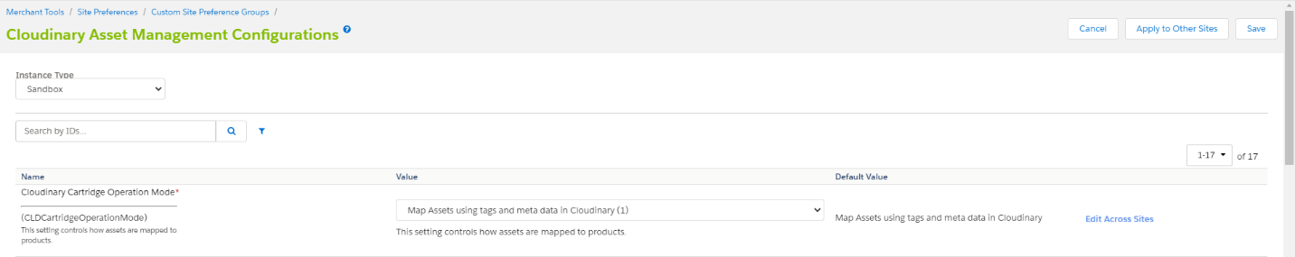

### PLP

* Open storefront of the site and open PLP. Inspect the URL and verify that the product assets are from Cloudinary

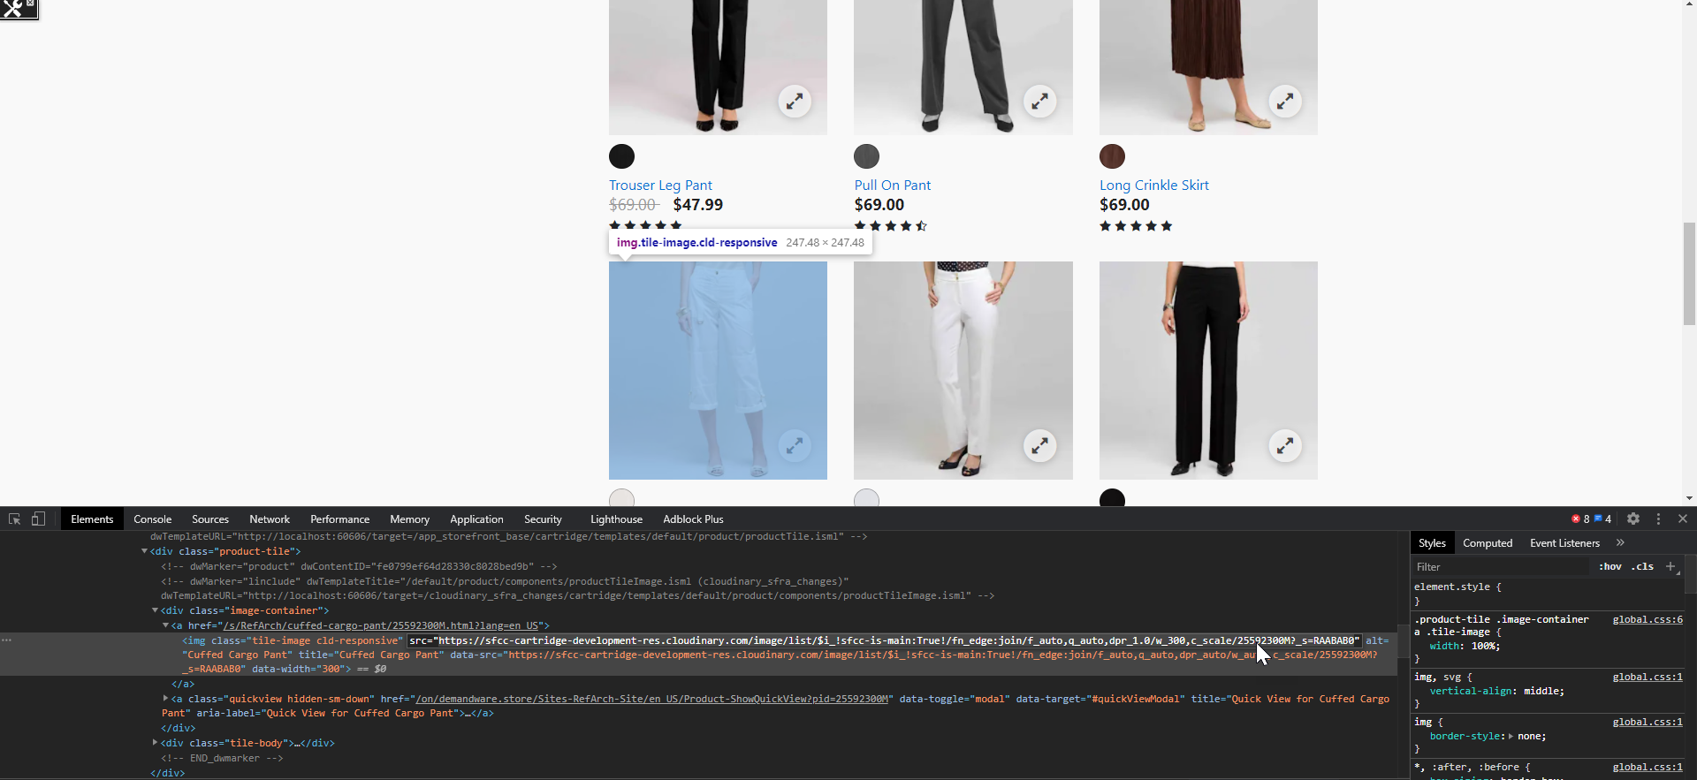

### Swatches

* Inspect on the swatches on PLP and verify that the swatches are from Cloudinary.

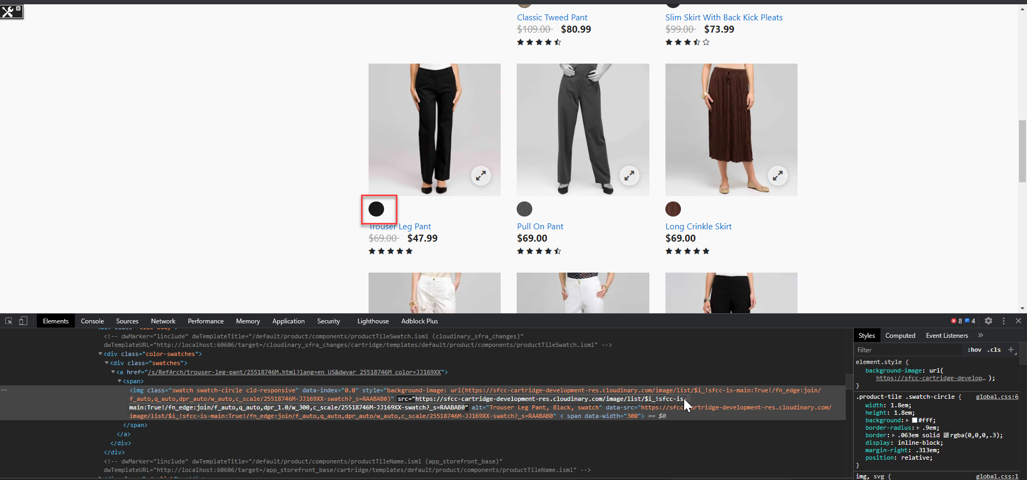

### Mini Cart

* Open storefront of the site and add product to the cart, Hover on the mini-cart and inspect the product image and verify that the product assets are from Cloudinary.

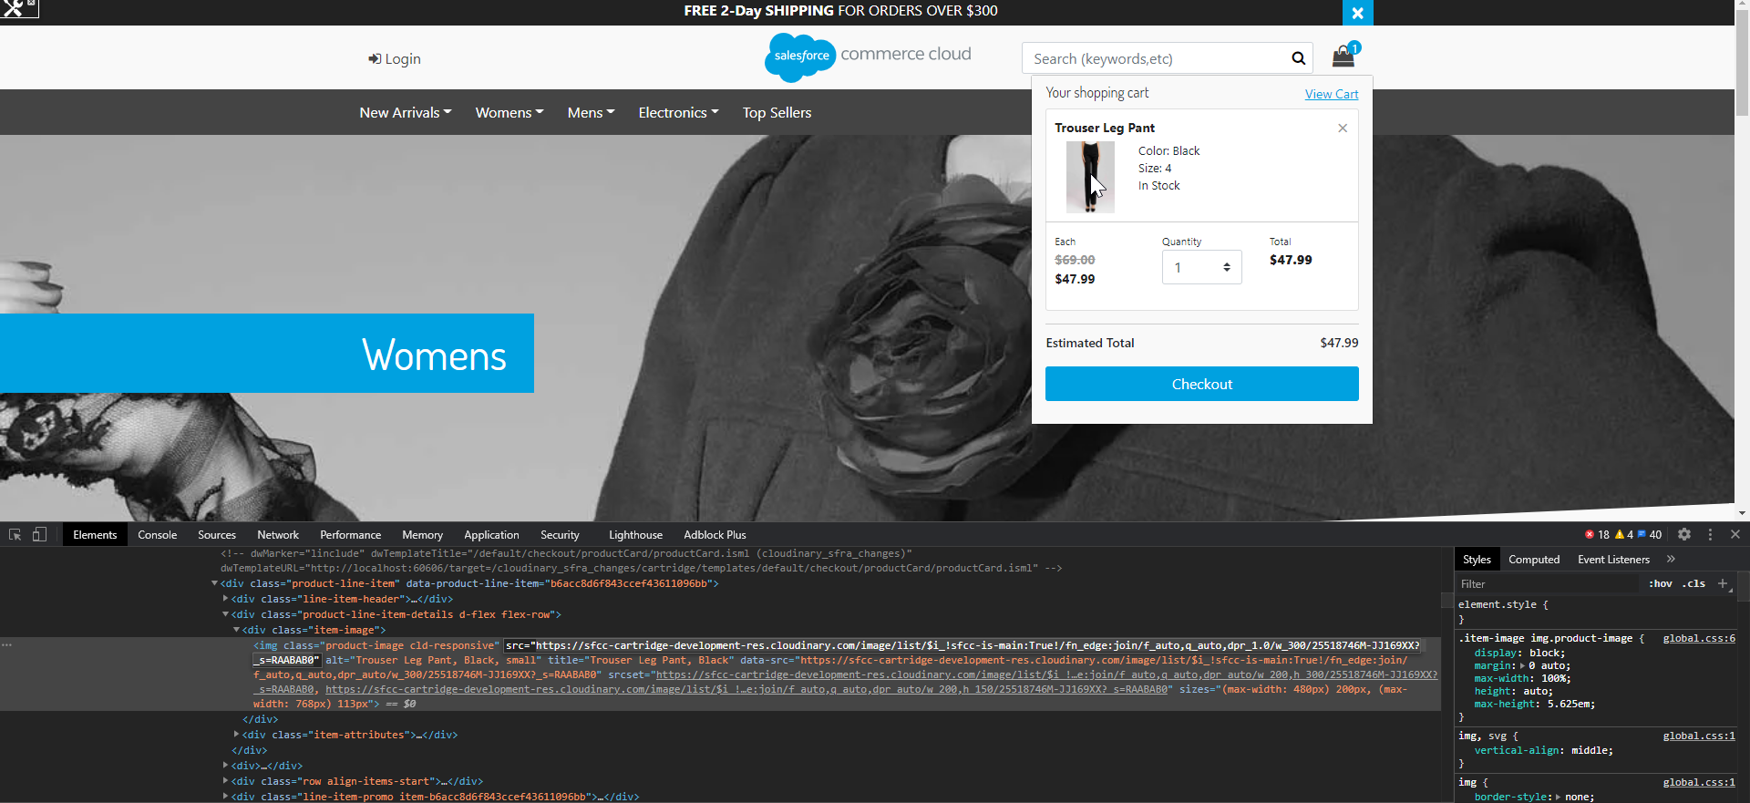

### Cart

* Open storefront of the site add product to cart and open cart page, now inspect the product image and verify that product assets are from Cloudinary.

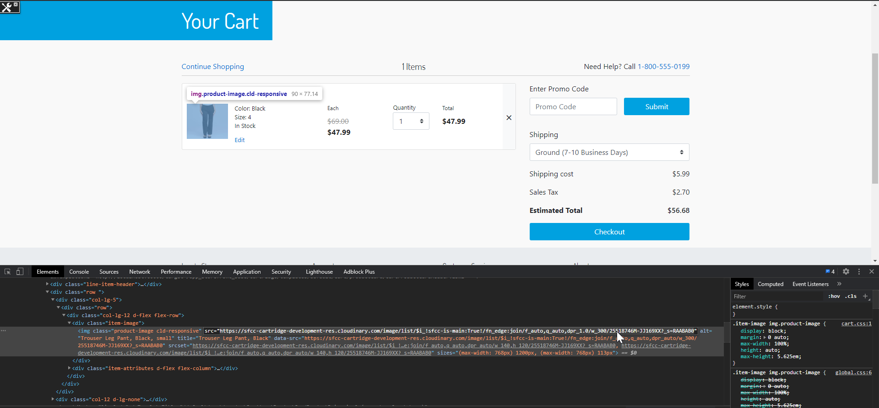

### Shipping

* Open storefront of the site, add product to cart and proceed to checkout. On the shipping page inspect the product image and verify that product assets are from Cloudinary

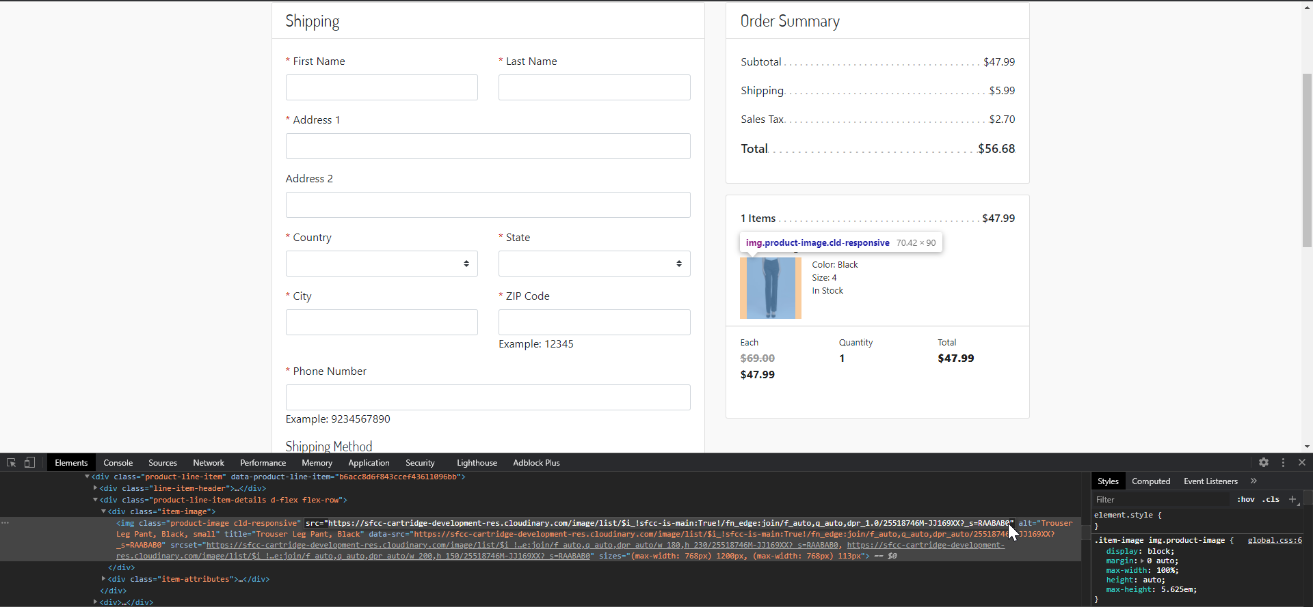

### Cloudinary Gallery Widget for PDP

#### Global Level

* Open Business Manager > Custom Preferences > Cloudinary Asset Management Configurations and select “Use Cloudinary Gallery On PDPs”, set this setting to YES



* Open Business Manager > Custom Preferences > Cloudinary Asset Management Configurations and go to “Cloudinary Gallery Look And Feel” add (CLDGalleryStyles) and save.
* Open storefront of the site, Open PDP of any product and see the effect of global level style.

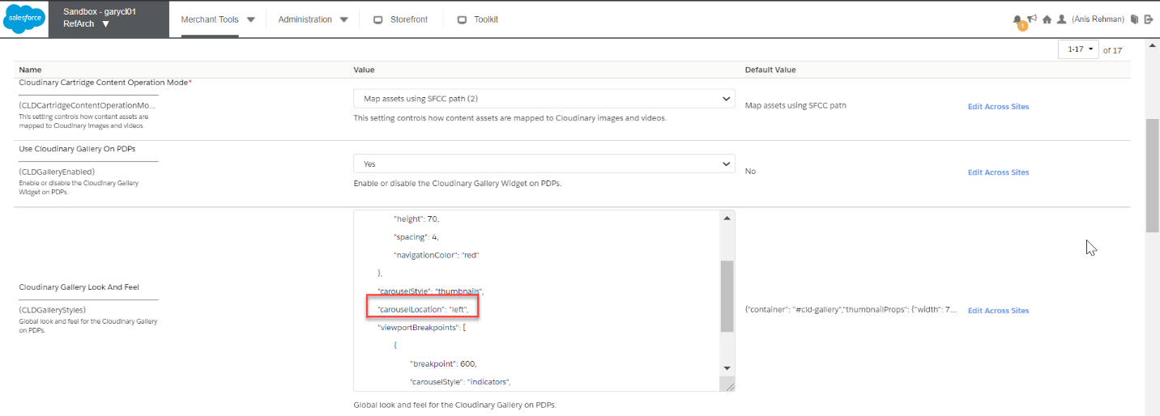

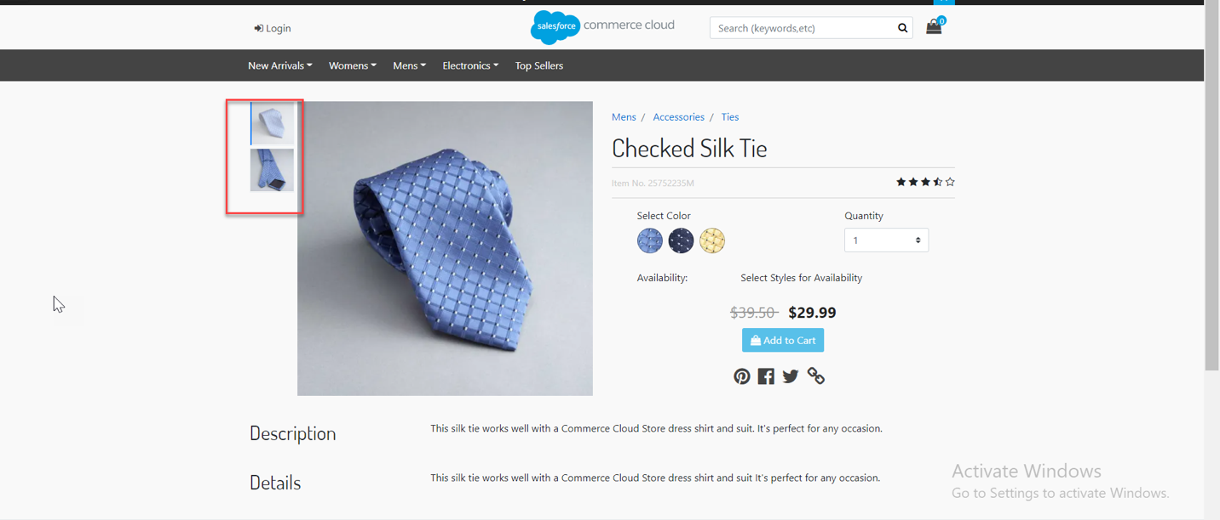

#### Product Level

* Open Business Manager, open any product where you want to add Cloudinary gallery style, add the styles and save it. Open storefront of the site and open that product where gallery styles were added.

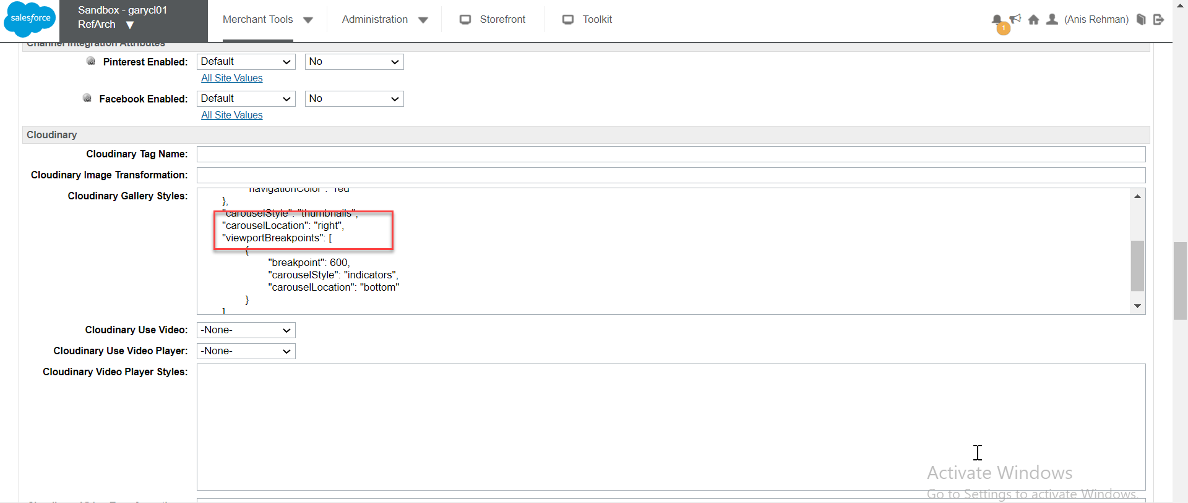

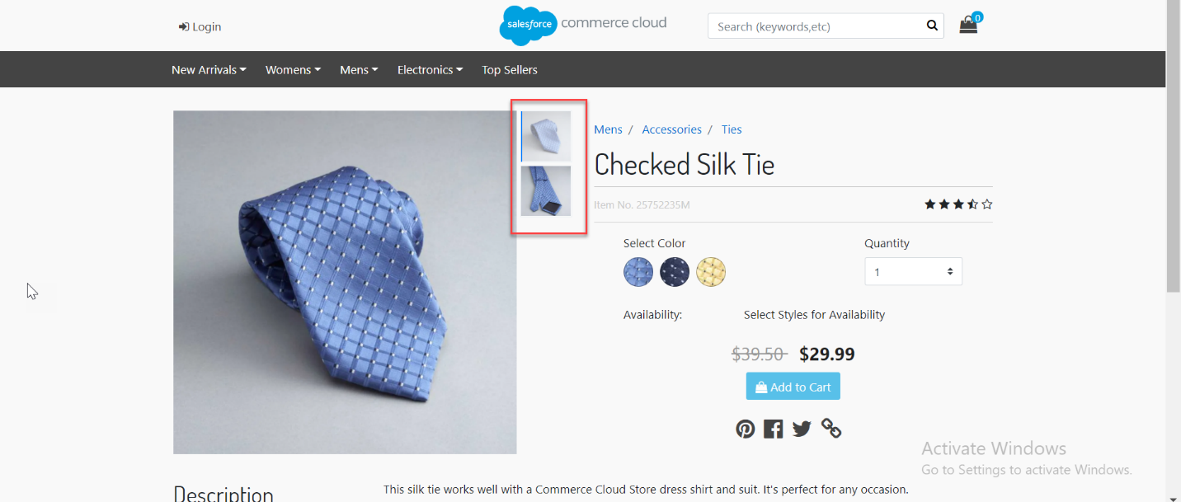

#### Variation Level

* Open Business Manager, open variant of any product, add Cloudinary gallery style to the custom attribute and save it. Open storefront, navigate to the product page and select the specific variant to see the results.

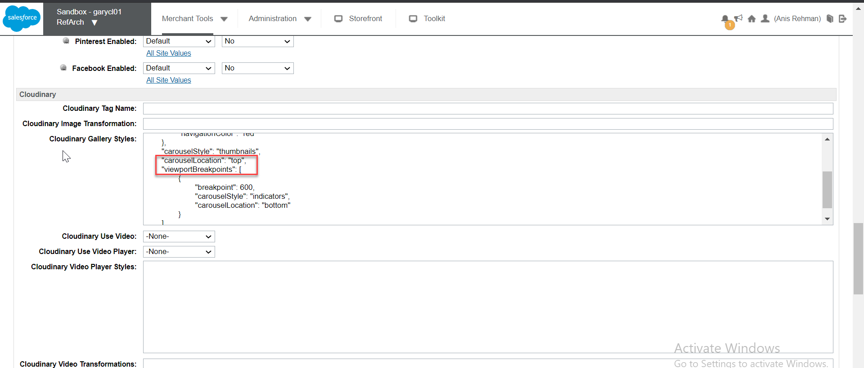

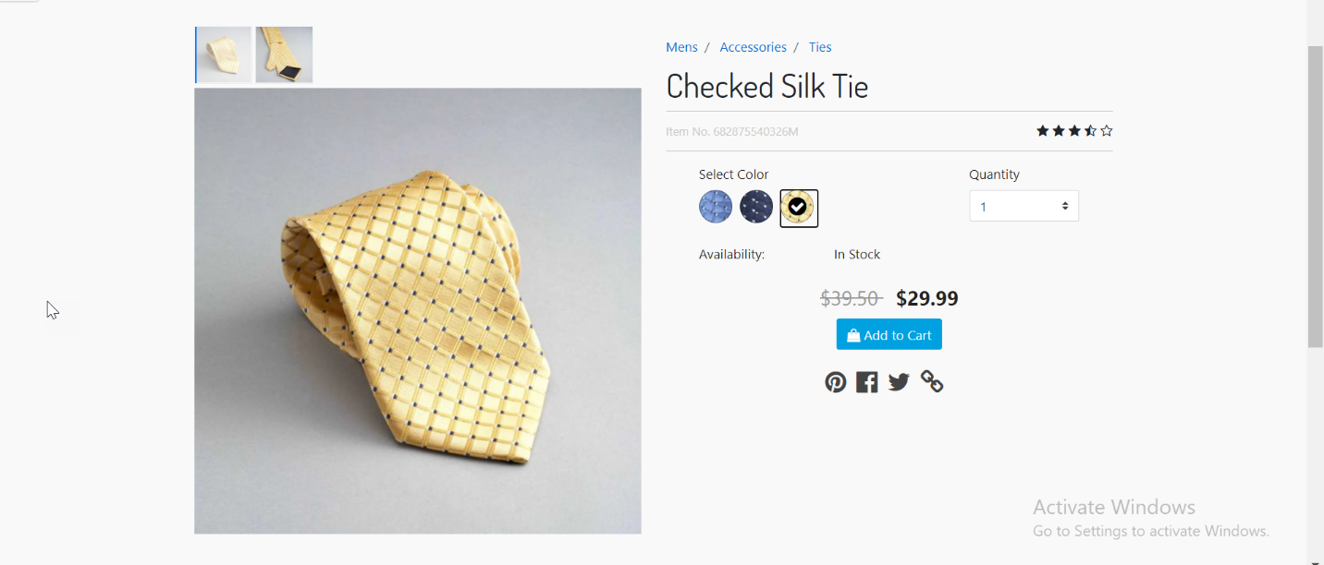

### Cloudinary Video Player

* Open Business Manager > Custom Preferences > Cloudinary Asset Management Configurations and enable “Use Cloudinary Video Player”



#### Global Level

* Open Business Manager > Custom Preferences > Cloudinary Asset Management Configurations and go to “Cloudinary video player look and feel” add (CLDVideoPlayerStyle) and save.
* Open storefront of the site, open PDP of any product and see the effect of global level style.

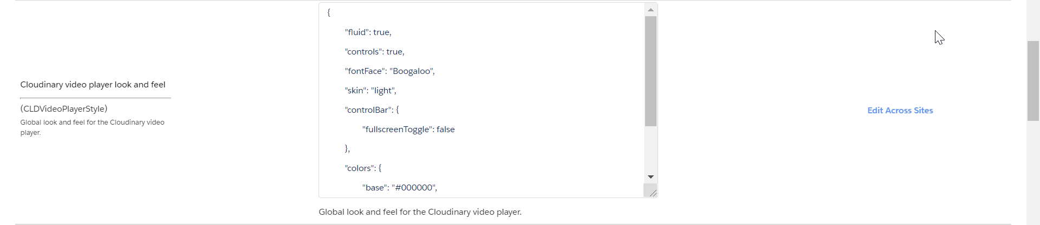

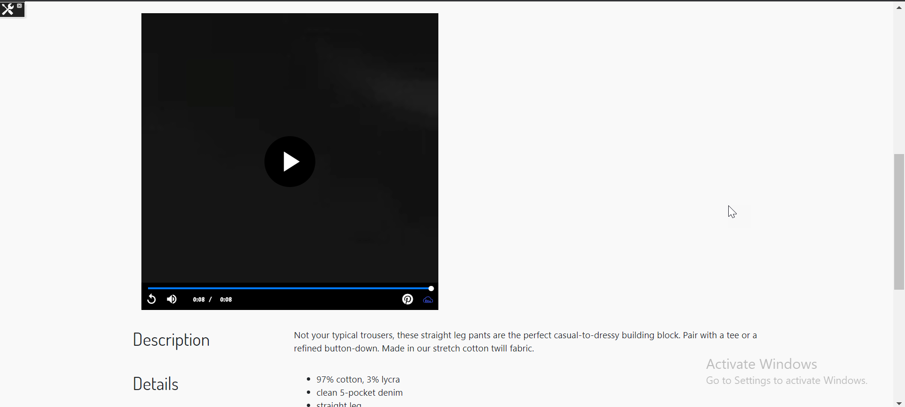

#### Product Level

* Open Business Manager, open any product where you want to add Cloudinary video player style, add the style and save. Open storefront of the site and navigate to product page where video player styles were added.



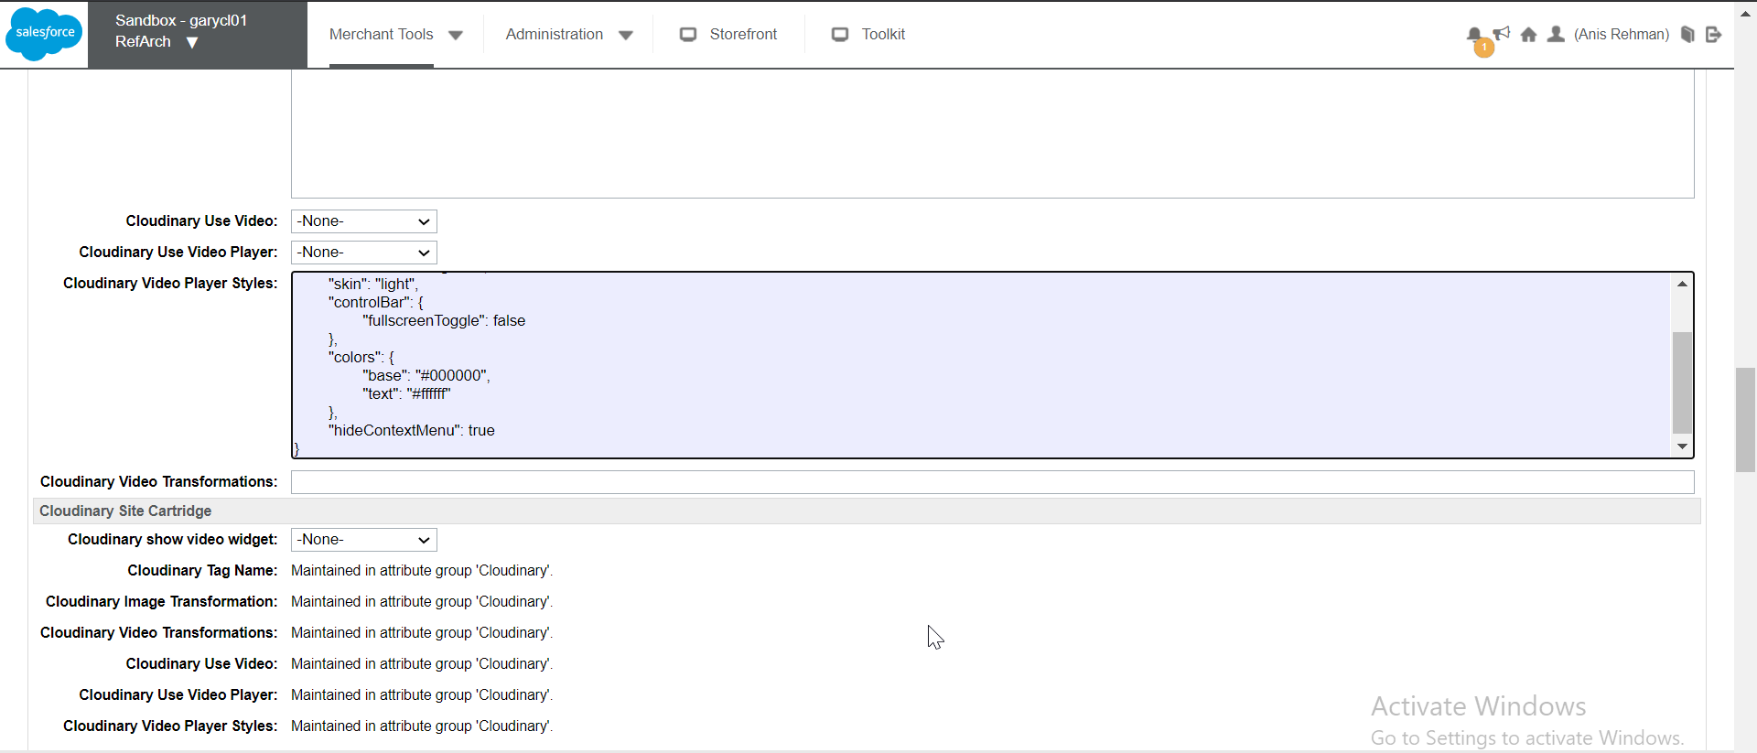

#### Variation Level

* Open Business Manager, open variant of any product where you want to add Cloudinary video player style and add the style and save. Open storefront of the site and open that product and select the specific variant to see the result.





### Product Asset Transformations

#### Global Level Transformations

* Open Business Manager > Custom Preferences > Cloudinary Transformation Configurations
* Add “Cloudinary Global Image Transformation”, open the storefront and see the result

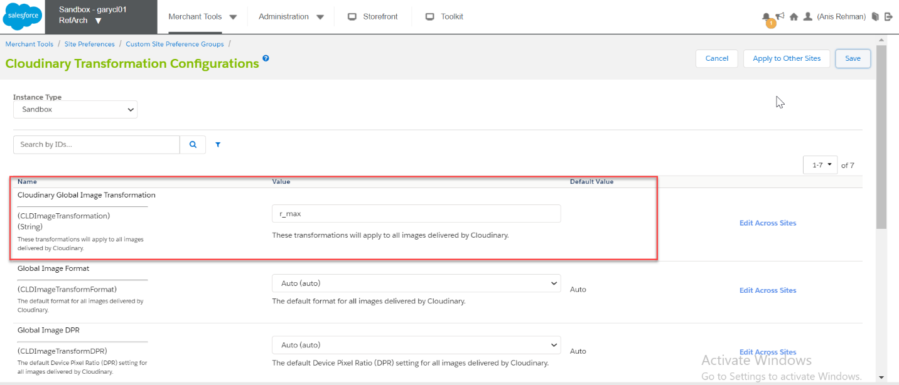

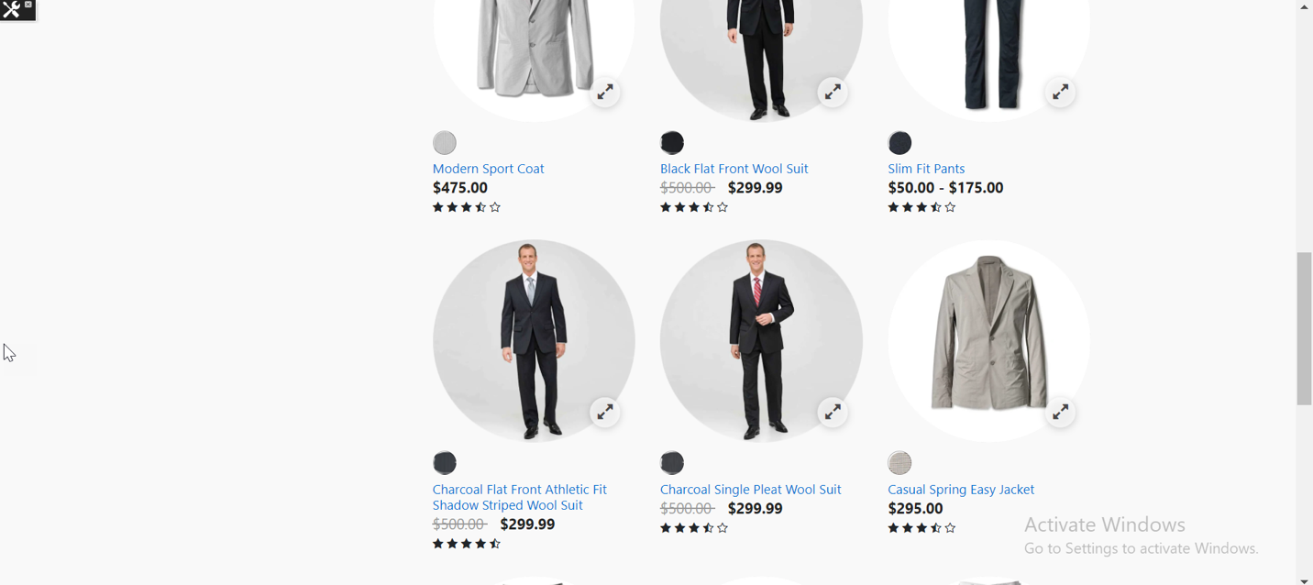

#### Catalog Level Transformations

* Open Business Manager, Open Catalog that is assigned to the site, now edit catalog and open Catalog Attributes
* Add “Cloudinary Image Transformation**”**

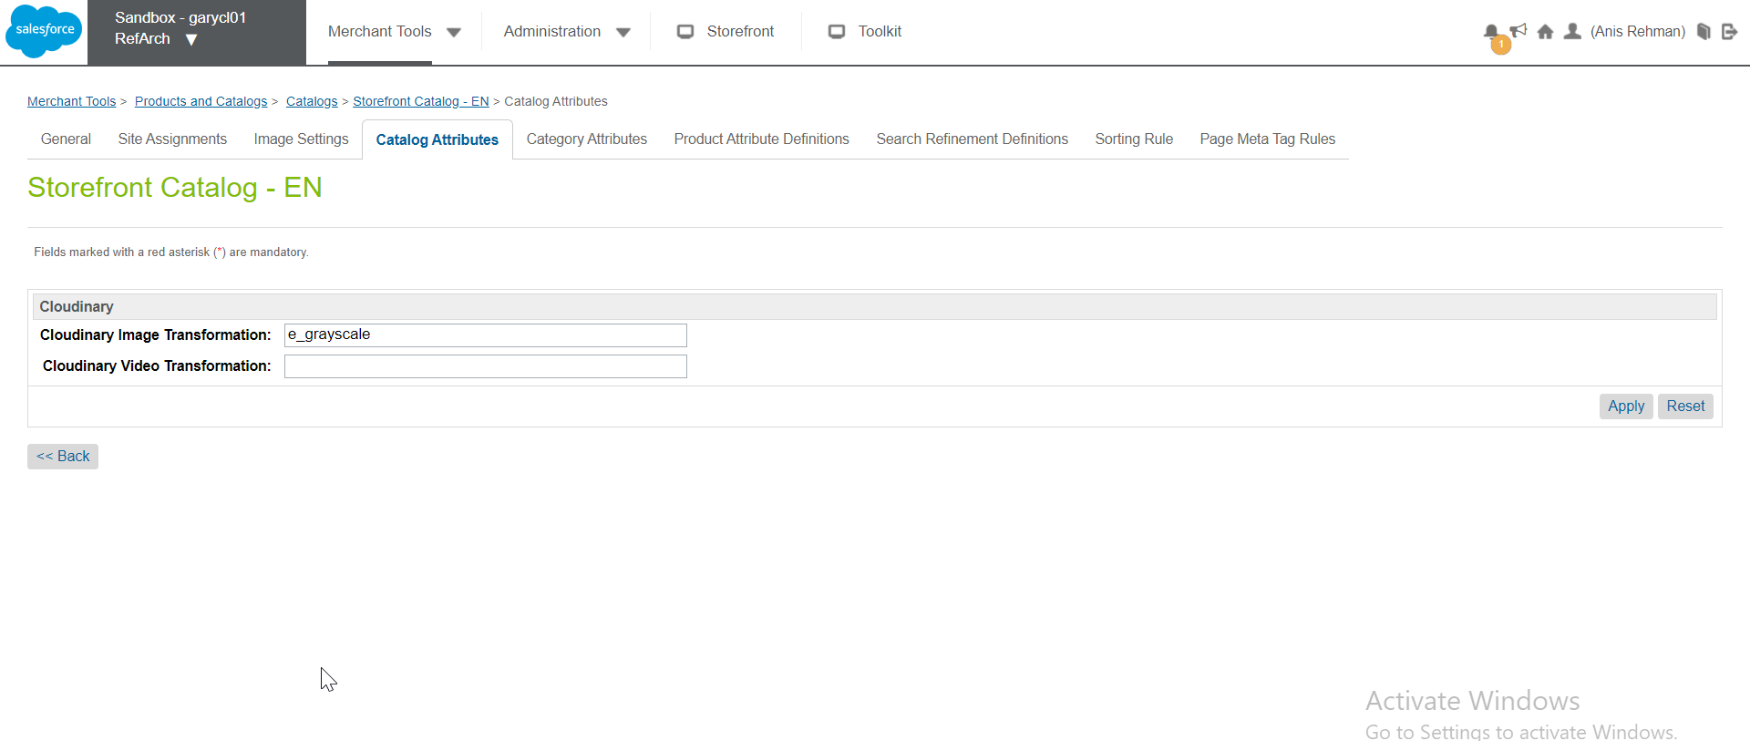

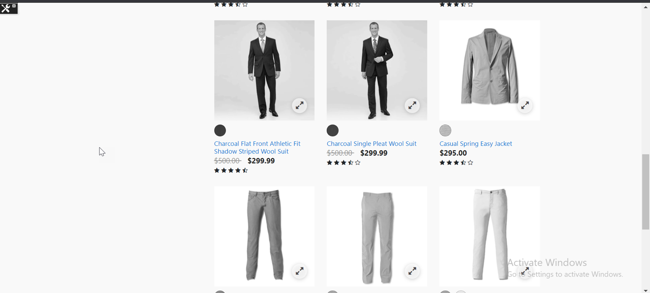

#### Product Level Transformations

* Open Business Manager and open any product where you want to set the transformations
* Add the transformations to relevant custom attribute and save changes.

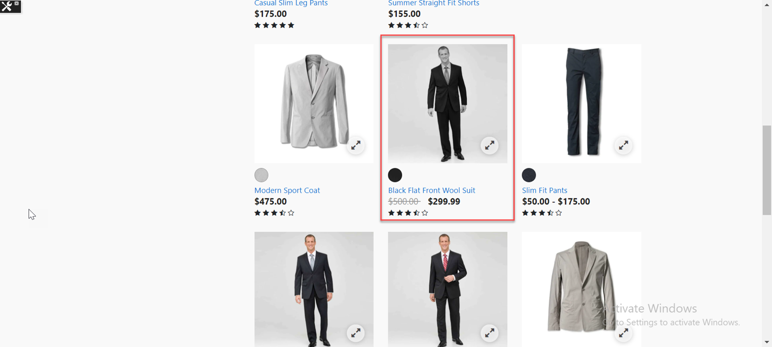

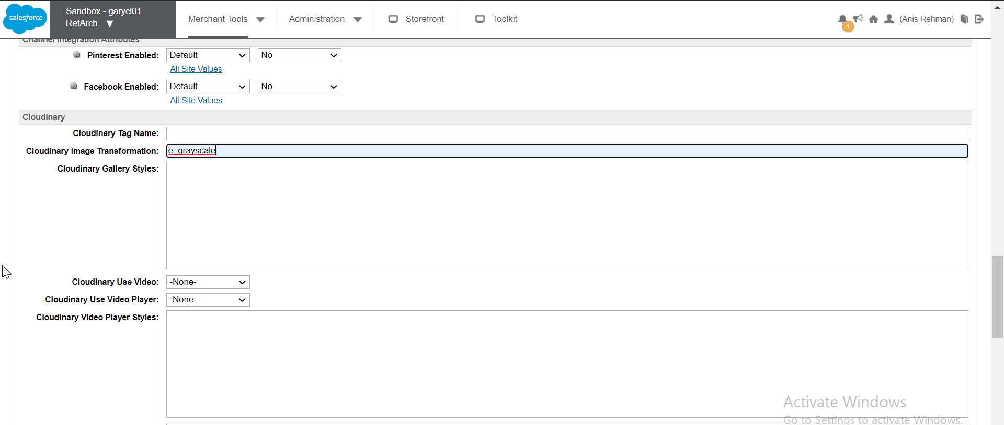

### Responsiveness

* If set to true, then Cloudinary will handle the responsiveness automatically for configured page type.

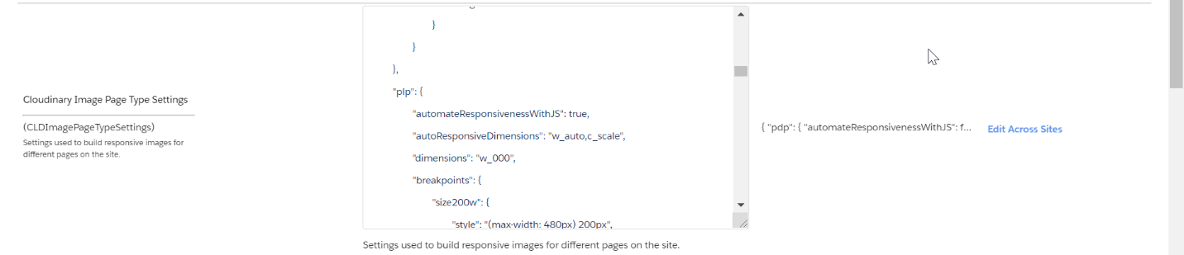

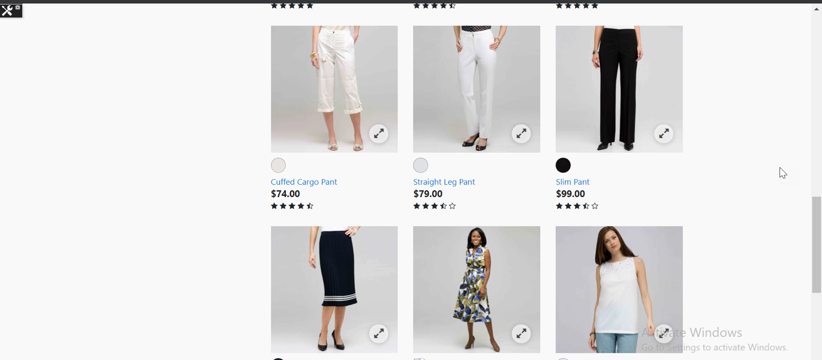

* If set to false, then given breakpoints in page setting (Custom Preference) will manage the responsiveness.

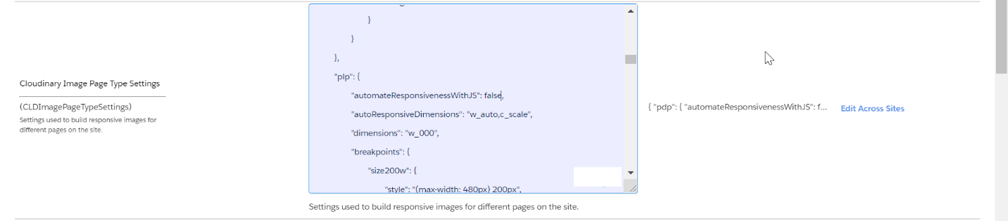

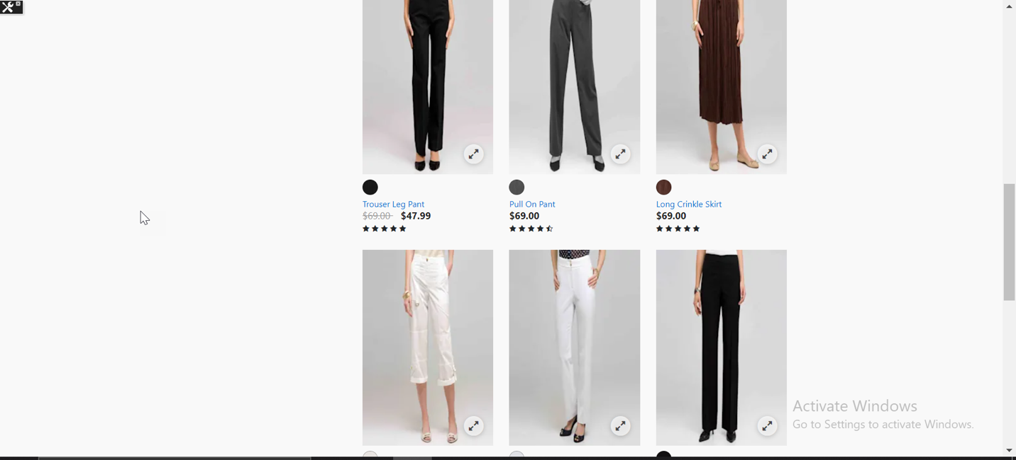

## Map Assets Using View-types in Catalog

* Open Business Manager > Custom Preferences > Cloudinary Asset Management Configurations and select the cartridge operation mode “Map Assets Using View-types in the Catalog”

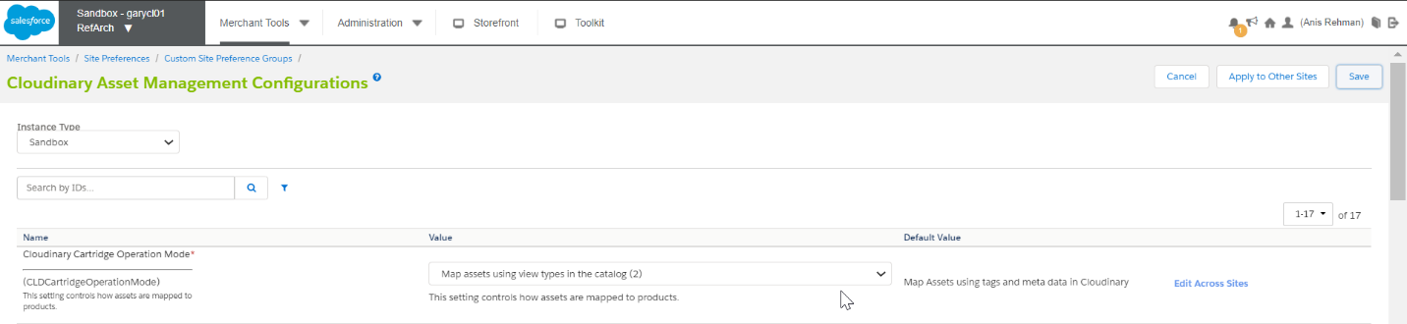

* When cartridge is enabled to operate in this mode then asset URLs are constructed from image path stored in view types defined in catalog.

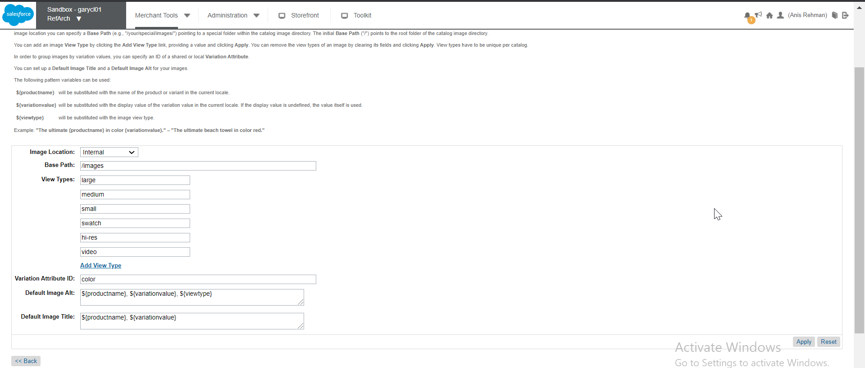

### PLP

* Open storefront and verify the image URLs are constructed using view type of products e.g (medium, small, large)

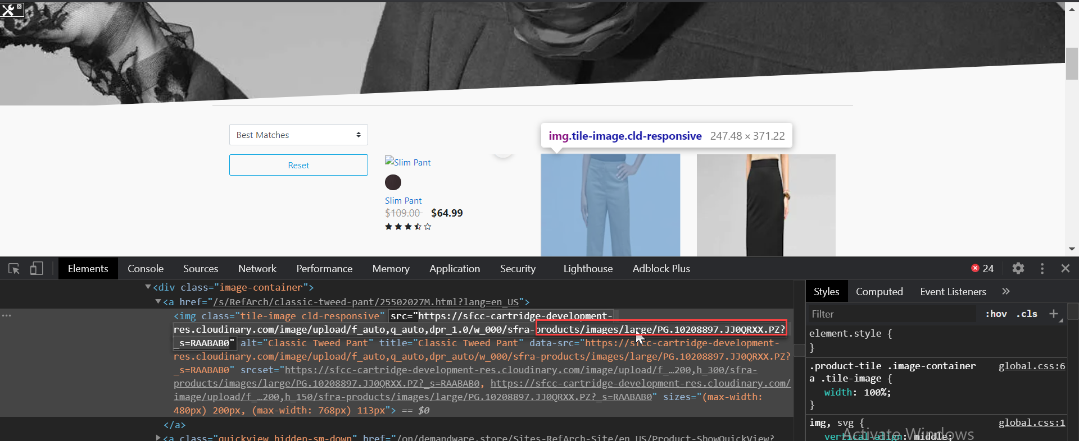

### Swatches.

* Open storefront of the site, open PLP and inspect swatch image, notice the swatch URL is generated using image path configured in “swatch” view type

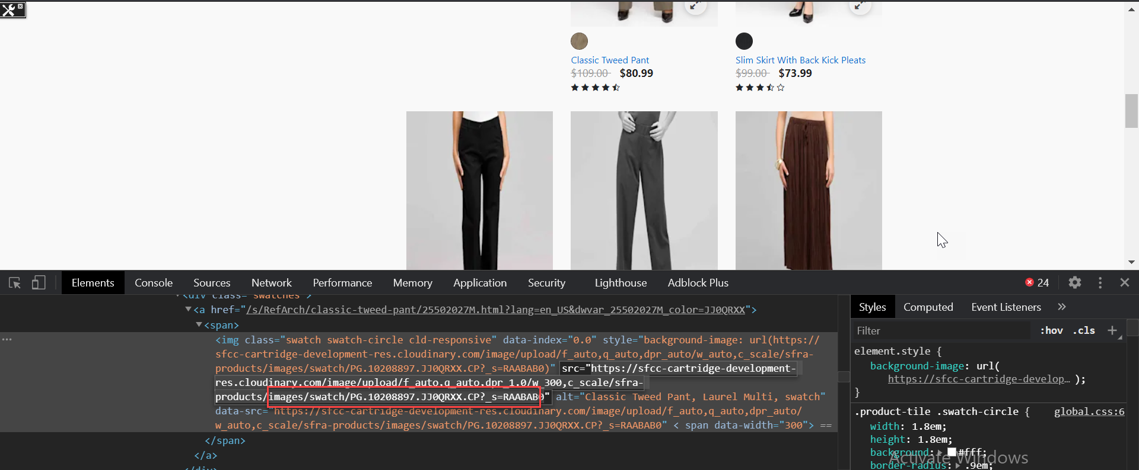

### Mini Cart

* Open storefront of the site and add product in the cart. Hoover over the mini-cart and inspect the product image and verify this time image URLs are constructed from view types e.g (medium, small, large).

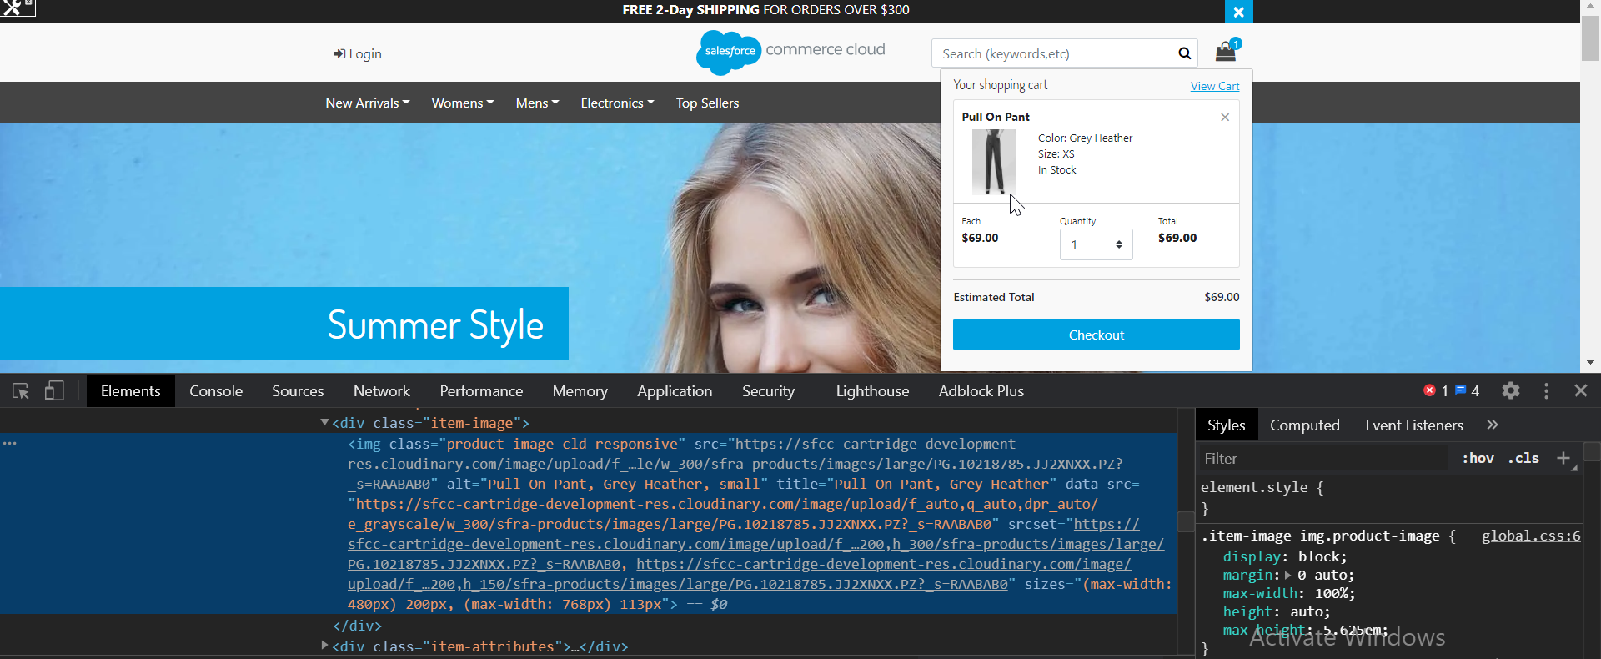

### Cart

* Open storefront of the site, add product in cart and open cart page now inspect the product image and verify this time image URLs are constructed from view types e.g (medium, small, large).

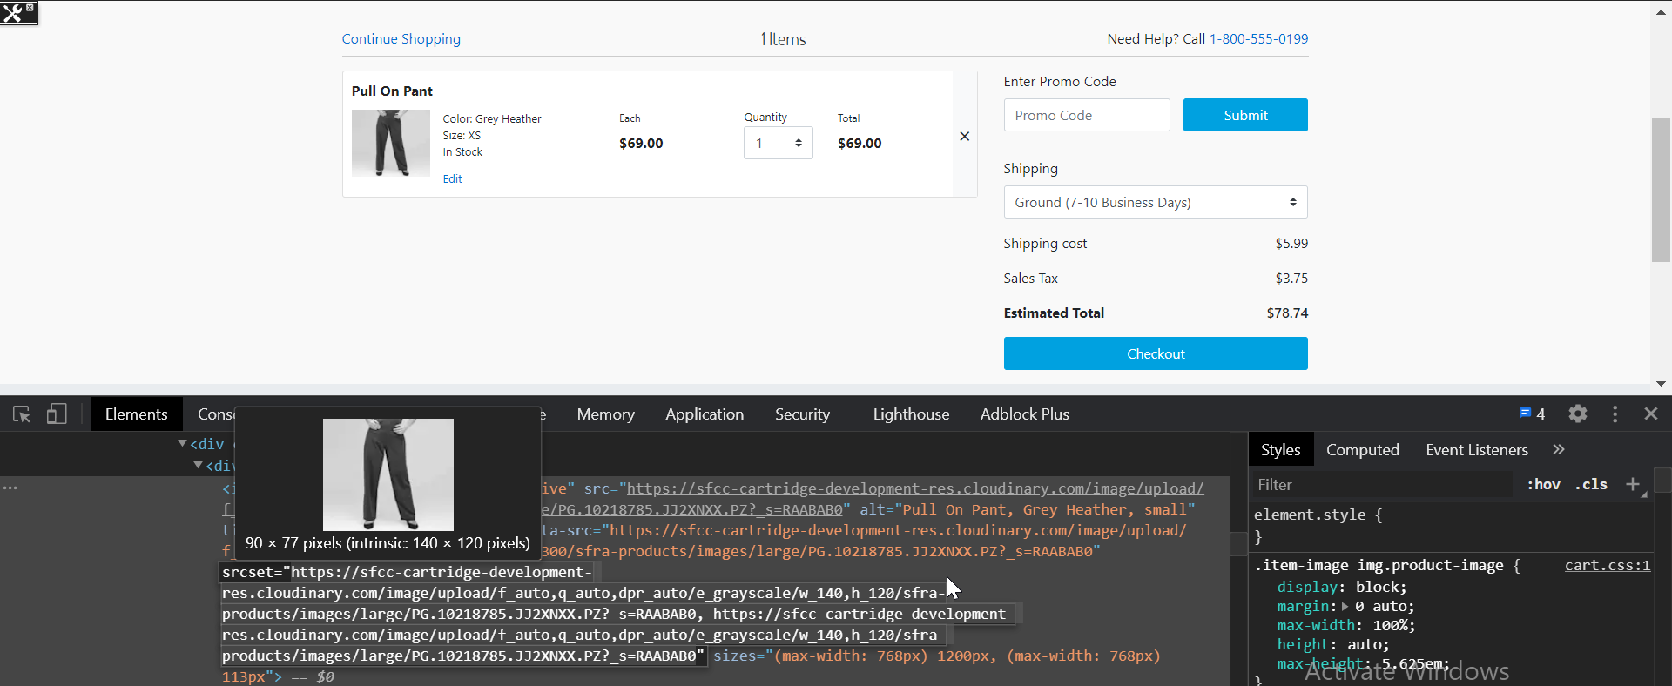

### Shipping

* Open storefront of the site, add product in the cart and proceed to checkout, On shipping page inspect the product image, verify this time image URLs are constructed from view types e.g (medium, small, large).

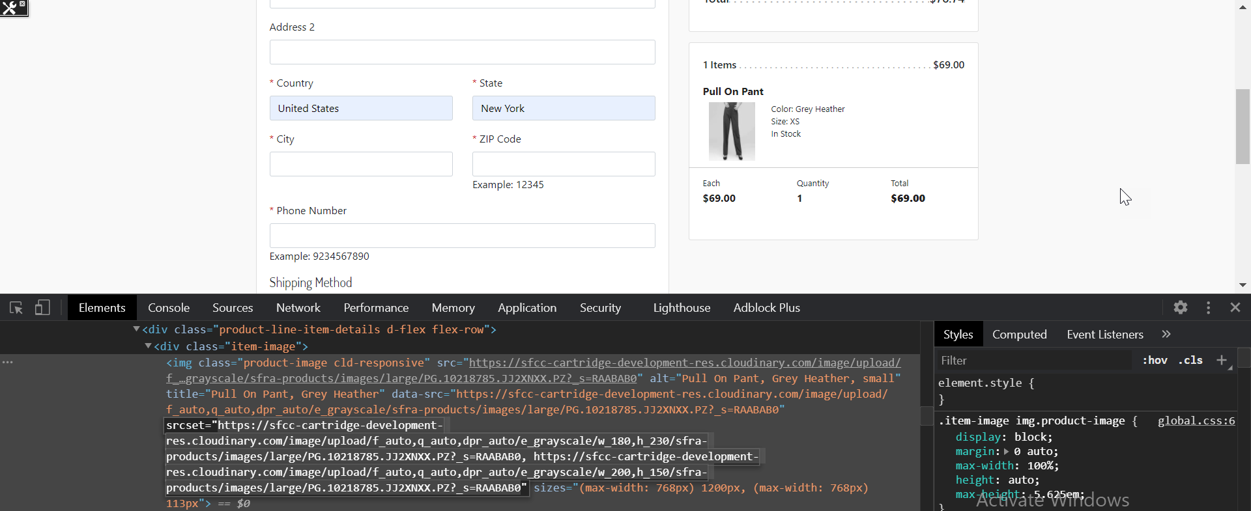

### Cloudinary Gallery Widget

* Open Business Manager > Custom Preferences > Cloudinary Asset Management Configurations and select “Use Cloudinary Gallery On PDPs” set this setting to YES

#### Global Level

* Open Business Manager > Custom Preferences > Cloudinary Asset Management Configurations and go to “Cloudinary Gallery Look And Feel”, add (CLDGalleryStyles) and save.
* Open storefront of the site, open PDP of a product and see the effect of global level style





#### Product Level

* Open Business Manager, open any product where you want to add Cloudinary gallery style, add the style and save. Open storefront of the site and navigate to product where gallery styles were added.





#### Variation Level

* Open Business Manager, open variant of a product where you want to add Cloudinary gallery style, add the style and save. Open storefront of the site and navigate to PDP, select the specific variant to see the result.





### Cloudinary Video Player

* Open Business Manager > Custom Preferences > Cloudinary Asset Management Configurations and enable “Use Cloudinary Video Player”



#### Global Level

* Open Business Manager > Custom Preferences > Cloudinary Asset Management Configurations and go to “Cloudinary video player look and feel”, add (CLDVideoPlayerStyle)and save.
* Open storefront of the site, open PDP of any product and see the effect of global level style.





#### Product Level

* Open Business Manager, open any product where you want to add Cloudinary video player style, add the style and save. Open storefront of the site and navigate to PDP where video player styles were added.





#### Variation Level

* Open Business Manager, open variant of the product where you want to add Cloudinary video player style, add the style and save. Open storefront of the site and navigate to PDP, select the specific variant to see the result.





### Product Asset Transformations

#### Global Level Transformations

* Open Business Manager > Custom Preferences > Cloudinary Transformation Configurations
* Add “Cloudinary Global Image Transformation”, open the storefront and see the result





#### Catalog Level Transformations

* Open Business Manager, Open storefront Catalog, edit the catalog and open Catalog Attributes
* Add “Cloudinary Image Transformation**”**





#### Product Level Transformation

* Open Business Manager and open a product where you want to set the transformations.
* Add the transformations to the relevant custom attribute and save changes.





### Responsiveness

* If set to true, then Cloudinary will handle the responsiveness automatically for specific page type.





* If set to false, then given breakpoints in page setting (Custom Preference) will manage the responsiveness.





## Use existing website URLs to auto upload into Cloudinary and deliver

* Auto upload mode is a simple mode of cartridge where merchants don't need to do anything like configuring tags or running jobs as in other mode of operations. When this mode is enabled cartridge retrieves an image from Cloudinary with a specific URL format, Cloudinary internally retrieves the image from SFCC and persist in their system. Afterwards this image is always served from Cloudinary without any extra delays.
* Open Business Manager > Custom Preferences > Cloudinary Asset Management Configurations and select the cartridge operation mode “Use existing website URLs to auto upload into Cloudinary and deliver”

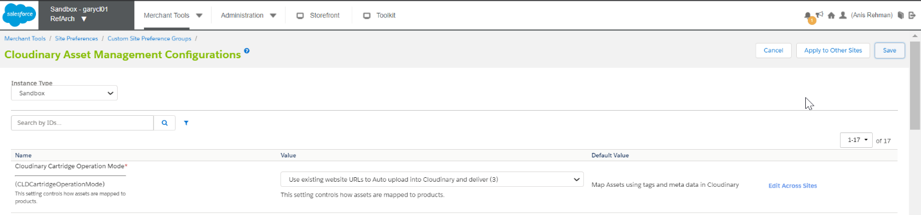

### PLP

* Open the storefront, navigate to PLP, inspect any product and notice the image URL reflects auto upload.

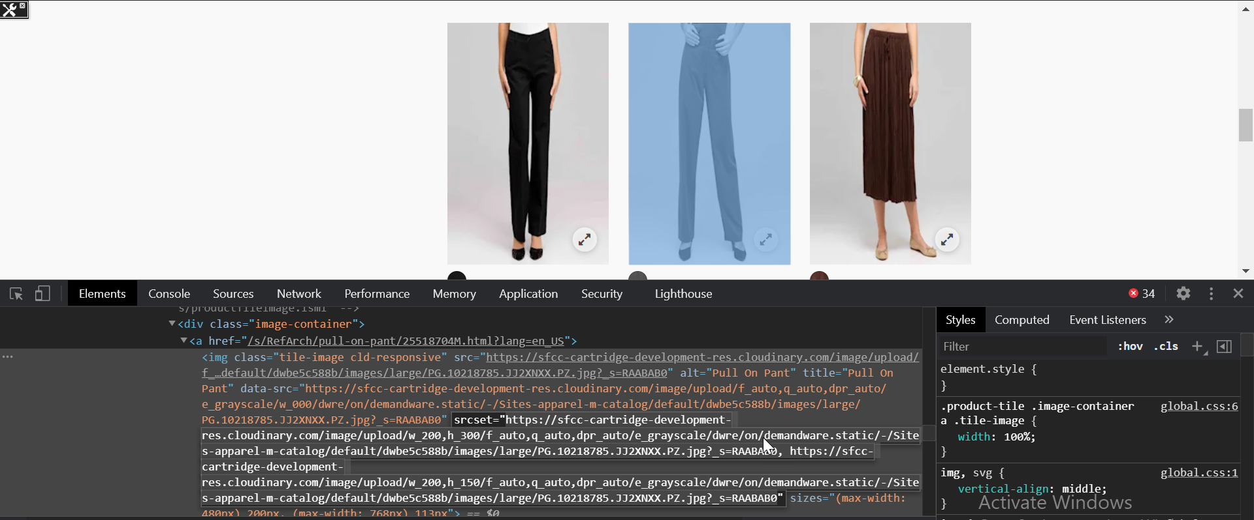

### Mini Cart

* Open the storefront, add a product to cart, hover over the mini cart. Inspect the product and notice the image URL reflects auto upload.

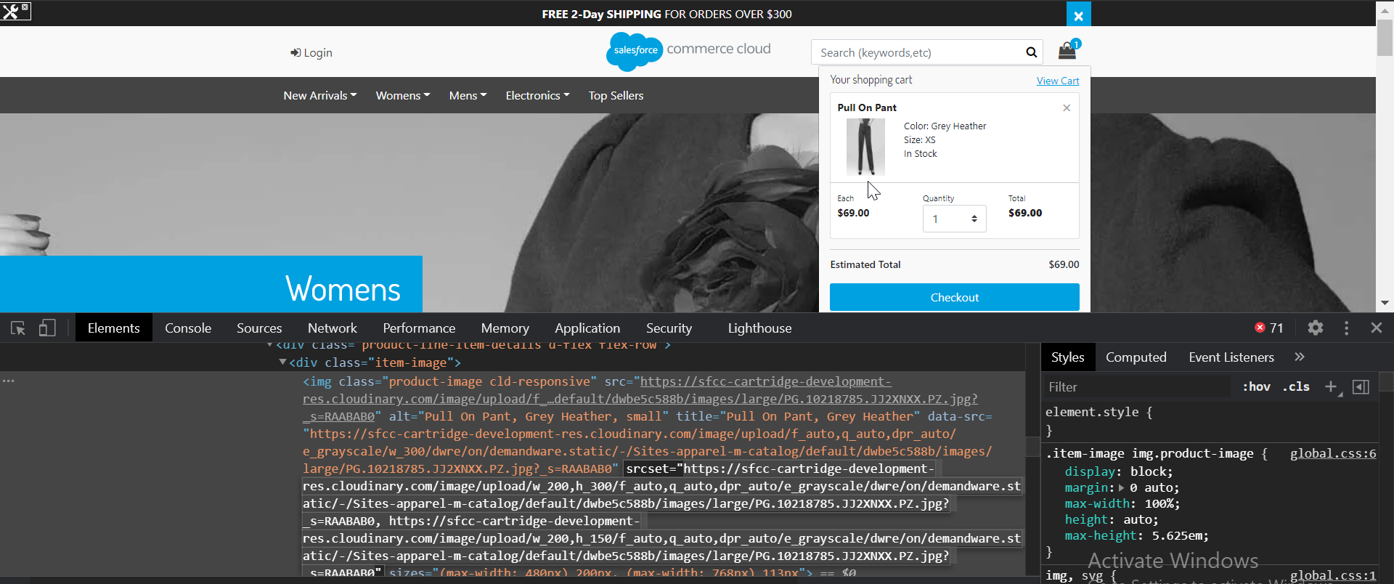

### Cart

* Open the storefront, add a product to cart, go to cart page. Inspect the product and notice the image URL reflects auto upload.

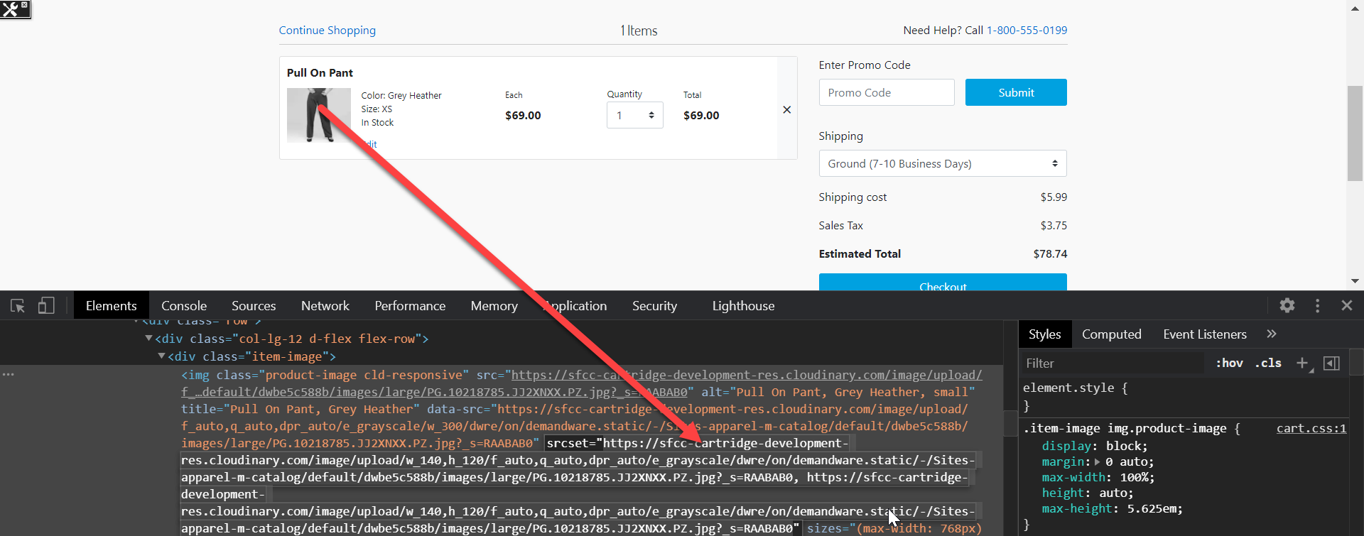

### Shipping

* Open the storefront, add a product to cart, proceed to checkout. Inspect the product and notice the image URL reflects auto upload.

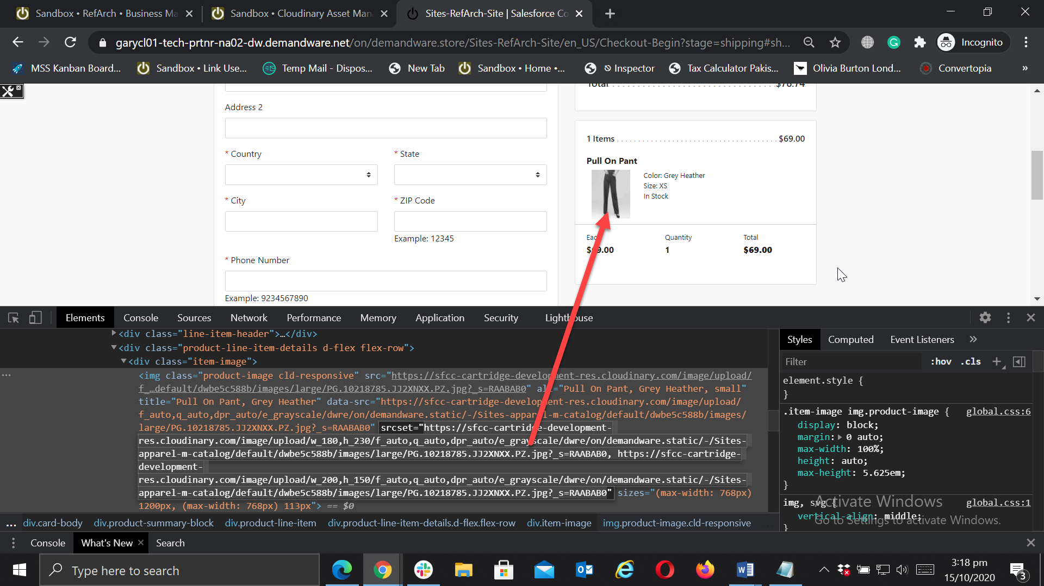

### PDP

* In Auto upload mode the images will not be visible on PDP by default. The cartridge returns the image URLS which can be used in SFCC image carousel or any other custom carousel to render images on PDP.
* The image URLs can be checked using test harness bundled with other Cloudinary cartridges. Enter the page type and product ID to retrieve image URLs for that product.

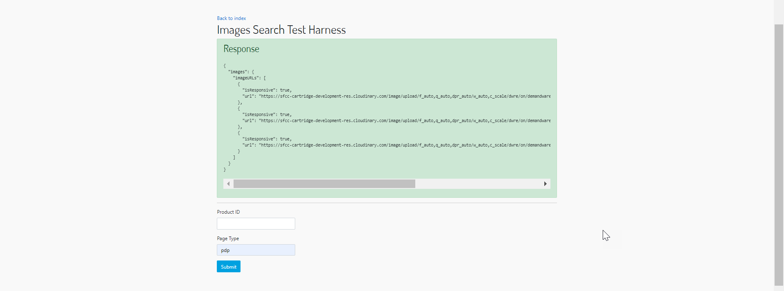

### Product Asset Transformations

#### Global Level Transformations

* Open Business Manager > Custom Preferences > Cloudinary Transformation Configurations
* Add “Cloudinary Global Image Transformation”, open the storefront and see the result





#### Catalog Level Transformations

* Open Business Manager, Open Catalog that is assigned to the site, edit catalog and open Catalog Attributes
* Add “Cloudinary Image Transformation**”**





#### Product Level Transformations

* Open Business Manager and open any product where you want to set the transformations
* Add the transformations to the relevant custom attribute and save the changes.





# Library Assets

## Map assets using SFCC Path

* Open Business Manager > Custom Preferences > Cloudinary Asset Management Configurations > “Cloudinary Cartridge Content Operation Mode” and select Map assets using SFCC Path

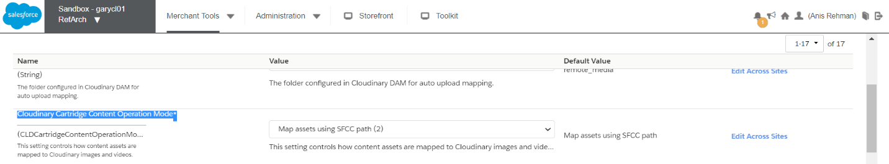

* In this mode cartridge will get images using SFCC absolute path

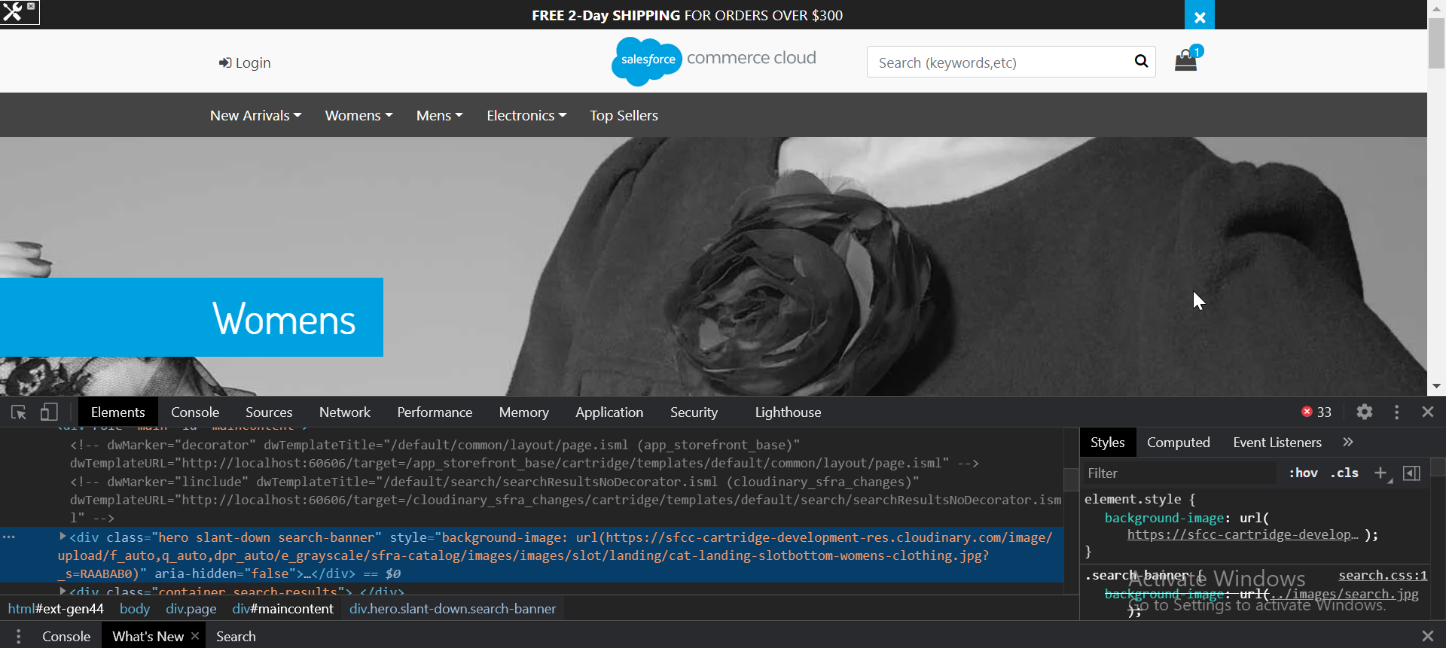

## Use existing website URLs to auto upload into Cloudinary and deliver

* Auto upload mode is a simple mode of cartridge, in this mode merchant don't need to do anything like other cartridge modes in which tags or job need to run. When this mode is enabled cartridge will automatically upload the assets to Cloudinary and fetch back to SFCC then render it.

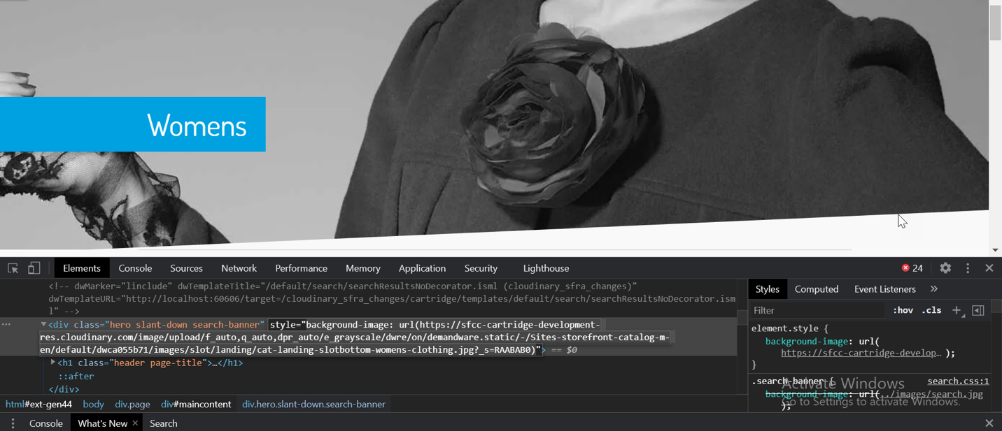

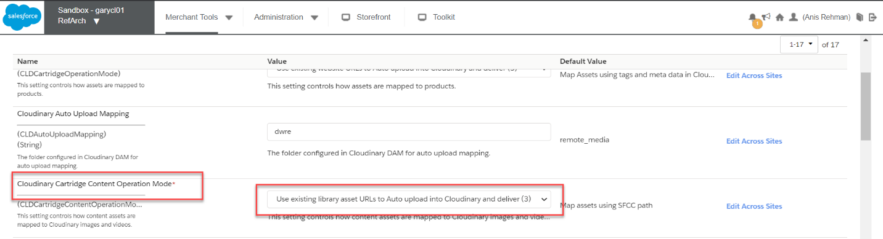

## Global Level Transformations

* Open Business Manager > Custom Preferences > Cloudinary Transformation Configurations
* Add “Cloudinary Global Image Transformation”, open the storefront and see the result



## Library Level Transformation

* Open Business Manager > Administrations > Content Libraries > Assigned Library > Library Attributes
* Add Cloudinary Image Transformations and see the result on storefront

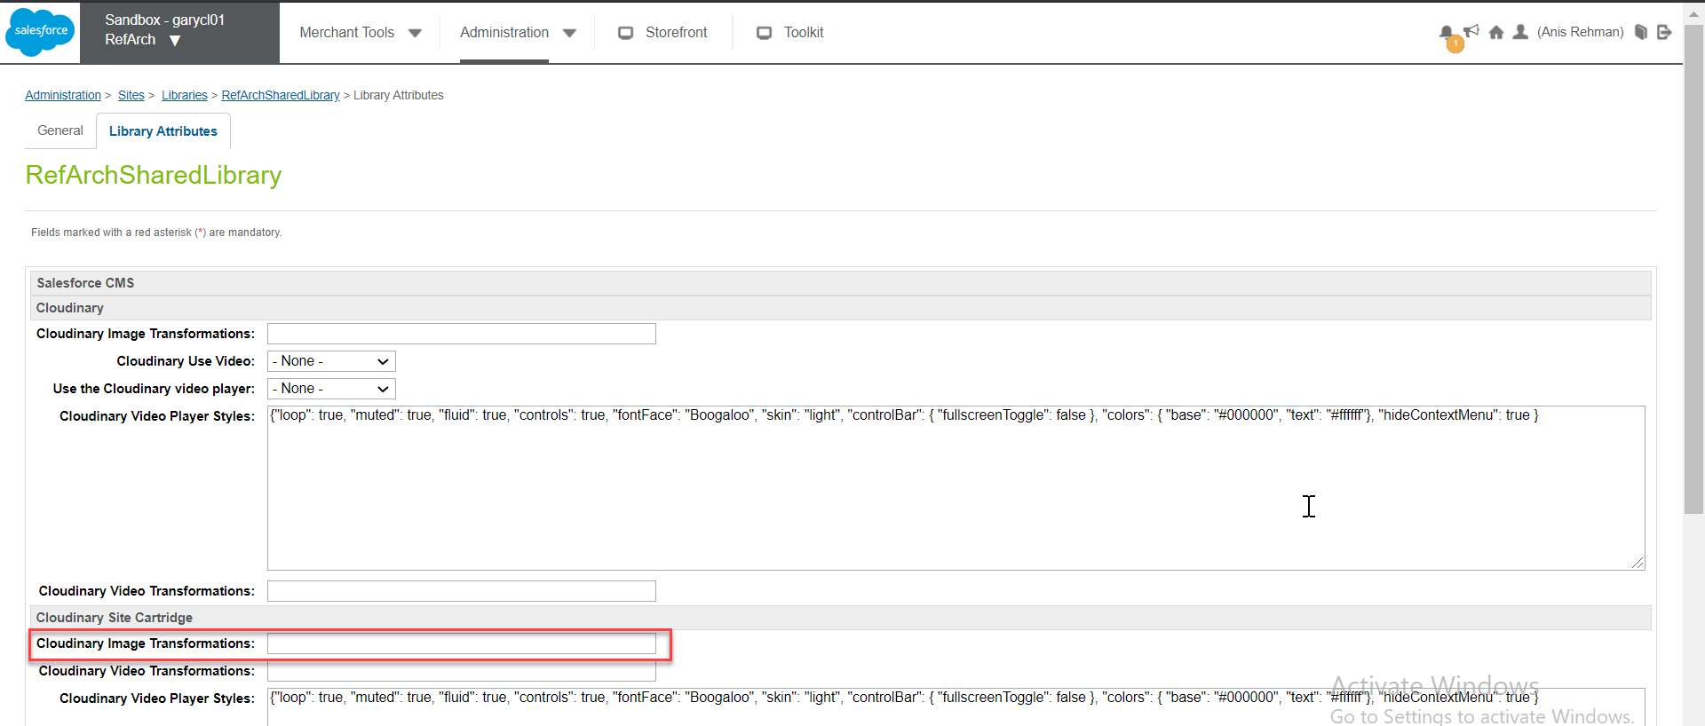



# Category assets

## Map assets using SFCC Path

* Open Business Manager > Custom Preferences > Cloudinary Asset Management Configurations > “Cloudinary Cartridge Content Operation Mode” and select Map assets using SFCC Path



* In this mode cartridge will get images using SFCC absolute path

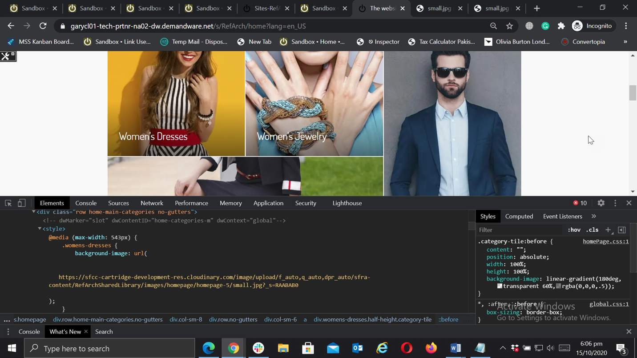

## Use existing website URLs to auto upload into cloudinary and deliver

* Auto upload mode is a simple mode of cartridge, in this mode merchant don't need to do anything likely other operation mode in which tags or job need to run. When this mode is enabled cartridge will automatically upload the assets to cloudinary and fetch back to SFCC then render it.



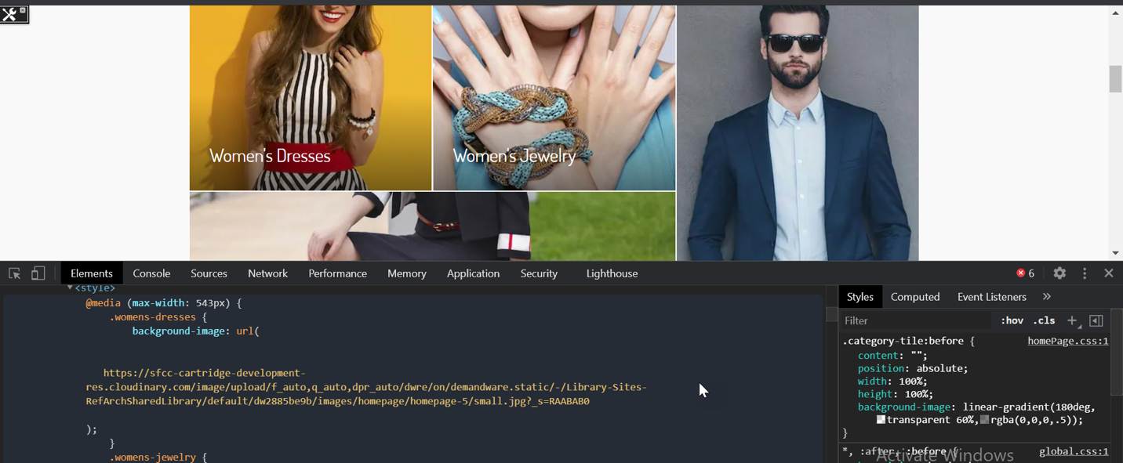

## Category Transformations

### Global level

* Open Business Manager > Custom Preferences > Cloudinary Transformation Configurations
* Add “Cloudinary Global Image Transformation”, open the storefront and see the result



### Catalog Level Transformations

* Open Business Manager, Open Catalog which is assigned to the site now edit the catalog and open Catalog Attributes
* Add “Cloudinary Image Transformation**”**



### Category Level Transformations

* Open Business Manager, Open Catalog > categories > Specific Category > Category attributes
* Add transformation and see the result on specific category.

